**Progression Documentation – Website Development**

**P14184295 – Sukhwinder Singh**

**Table of Contents**

1. Items utilised: 3

2. Github Setup 3

3. Fetching Flickr data with JSON 5

4. Created Interface design 7

4.1 Sequence 1 – Index Page 7

4.2 Sequence 2 – Opening Menu 8

4.3 Sequence 3 – Gallery Tab 9

4.4 Sequence 4 – Gallery Page 10

4.5 Sequence 5 – About Me 11

4.6 Sequence 6 – Contact Me 12

5. Started working on index.html 13

5.1 Added two more pages – hongkong.html and england.html 14

6. Styling 16

a. Errors encountered within the first section 19

6.2 Progress made after the errors 21

6.3 Menu creation 23

6.4 Responsive side of the site 26

6.5 Info content moved from Albums content 26

6.7 Navigation Bar responsive 27

6.8 Navigation bar finished 31

6.9 Image hover effect 32

6.10 Give Background to navigation bar when reached a certain offset 33

6.11 Content in first section animated 34

6.12 Slider 35

6.13 Modal for the images 36

6.14 3D flip effect 38

6.15 Fading In transition 40

7. Information Architecture and PARC 42

8. Validation HTML5 43

9. Sitemap 44

10. User Testing/Accessibility 44

References 45

# Items utilised:

* Photoshop
* HTML5
* CSS3
* JavaScript
* Bootstrap
* Flickr API

# Github Setup

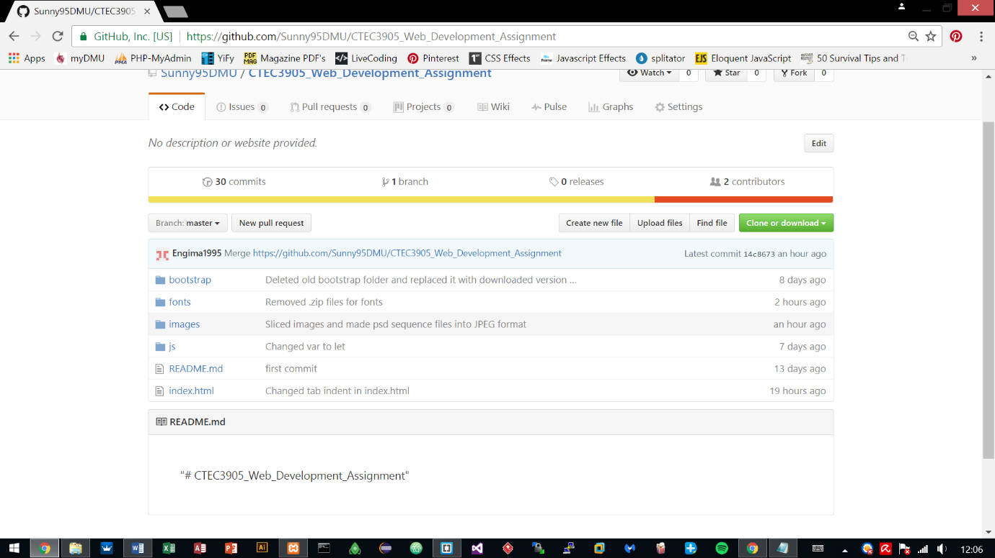The first step included signing up to Github and making a public account on Sunny95DMU with the repository CTEC3905_Web_Development_Assignment.

A copy of the repository stored on GitHub was downloaded/initialised as .git local repository on the local machine for pulling and pushing any changes to the development work on to the Github repository.

The structure of the folders and files are listed below and they represent the progress that has been made to the development for the past few weeks.

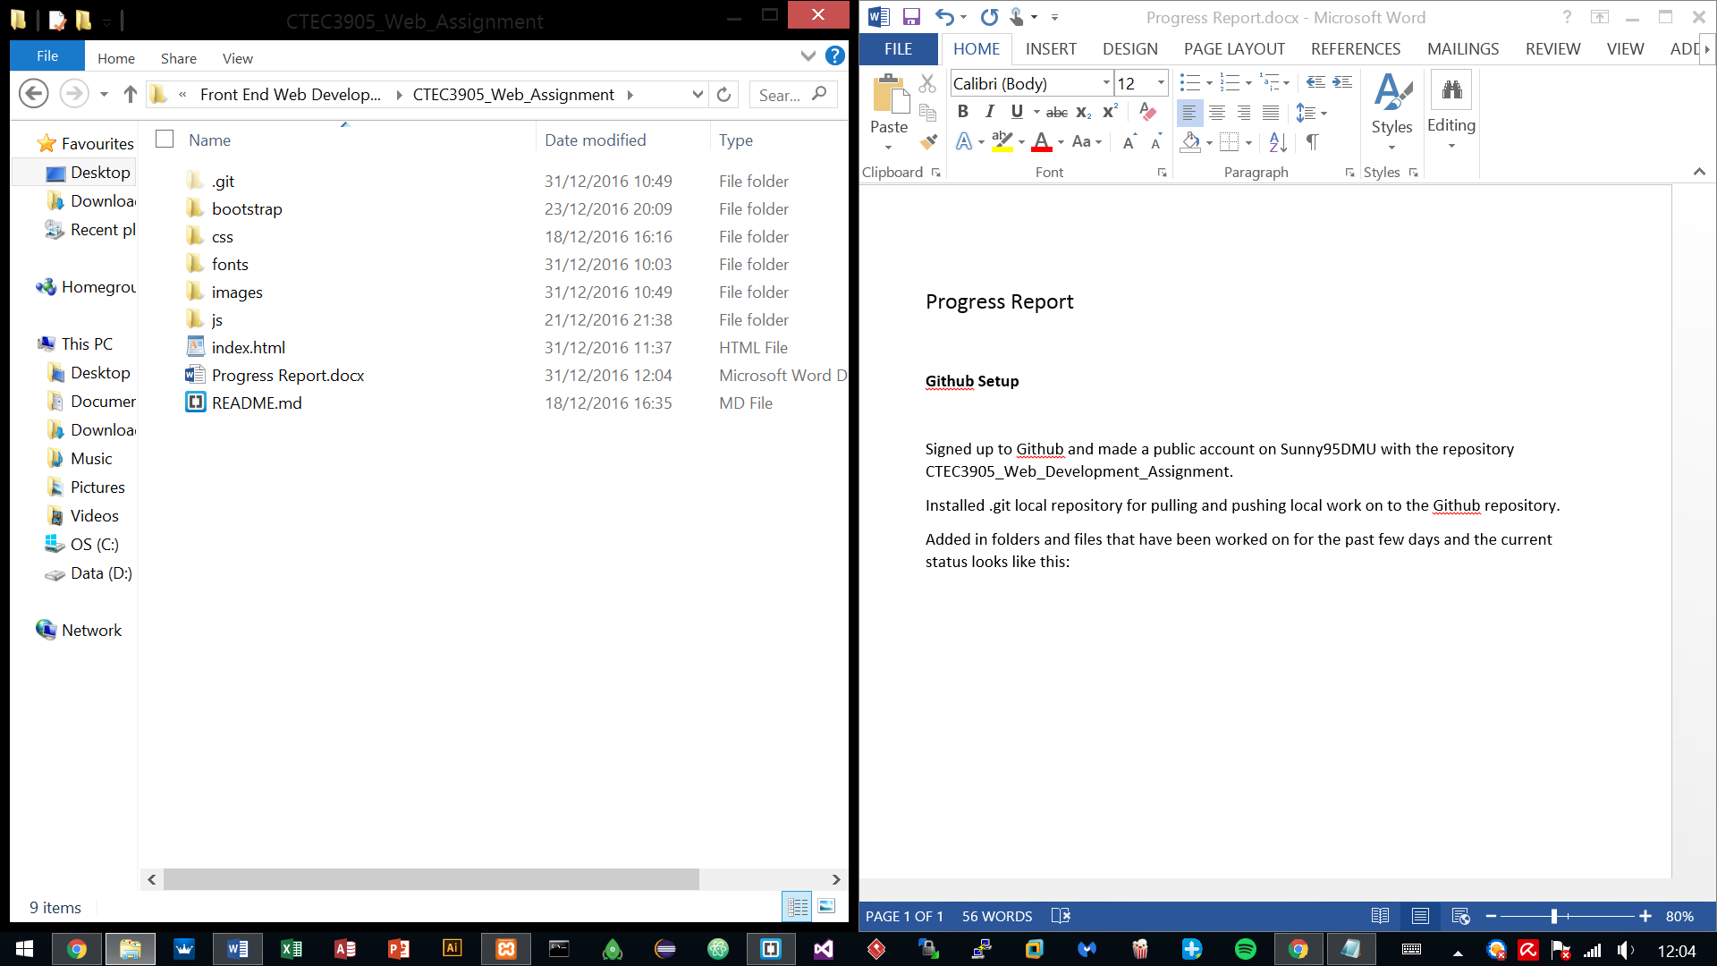

# Fetching Flickr data with JSON

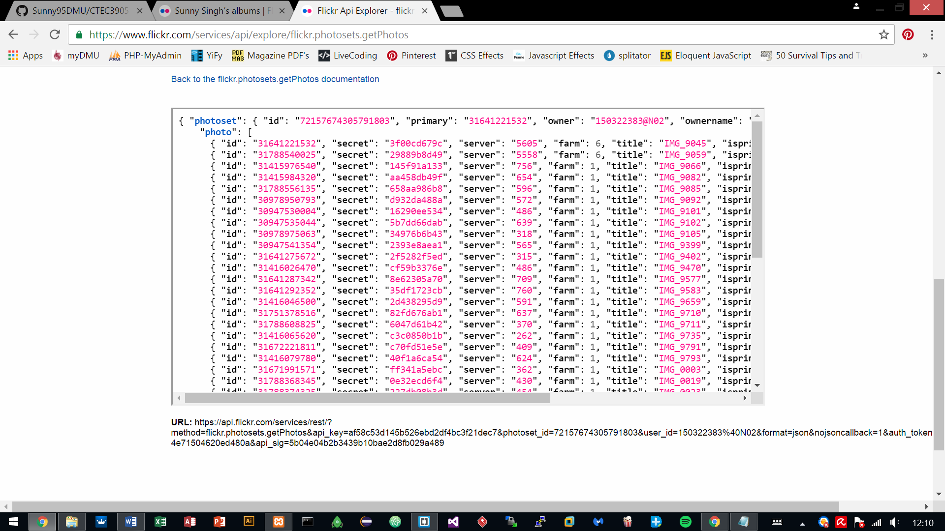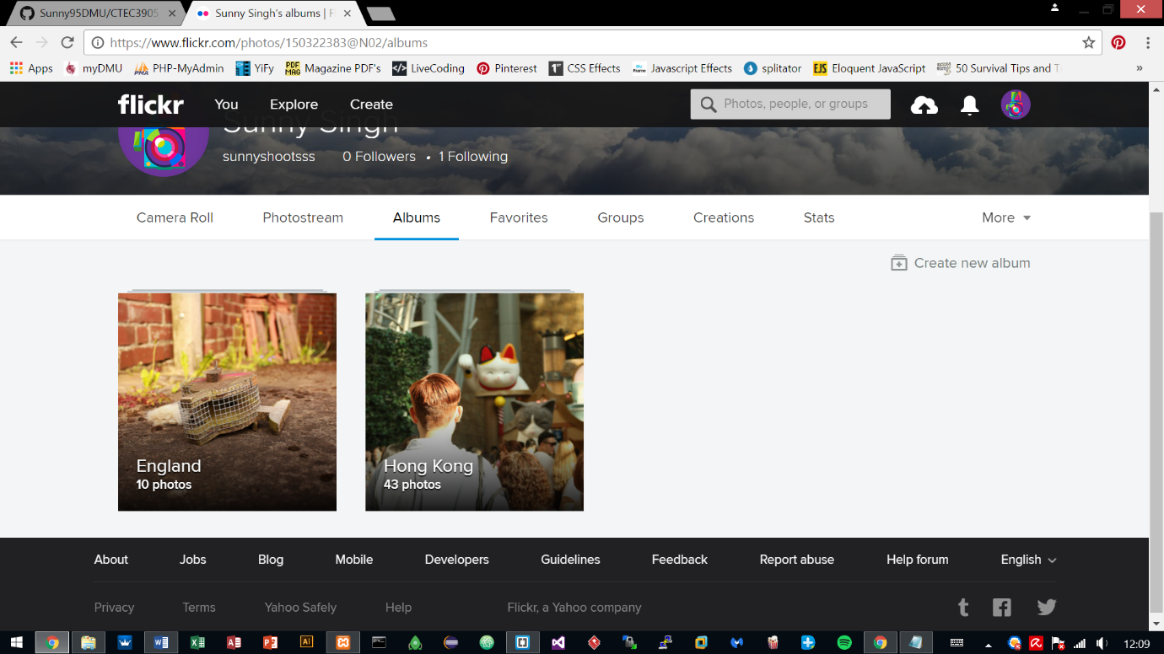This progress shows the uploading of the images to Flickr and utilising Flickr API to retrieve those uploaded images via JSON, to show them categorically within the website pages.

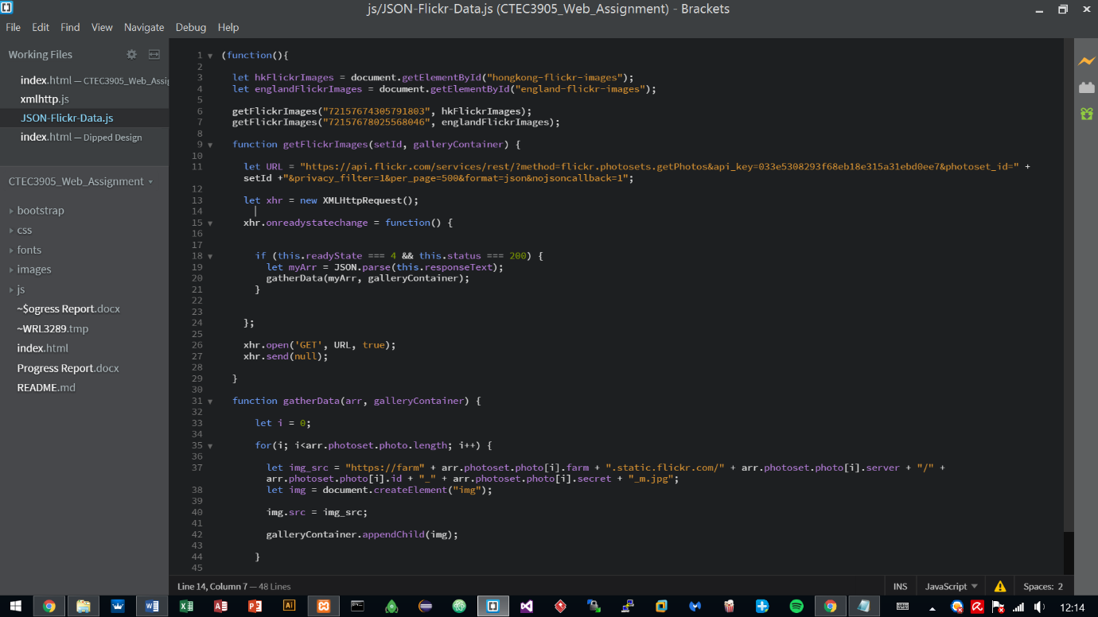The API key provided by the Flickr site was used with JSON formatting for connecting to the Flickr server. This in return gave an array of the uploaded images, which is stored in their own separate sections representing the country album title.

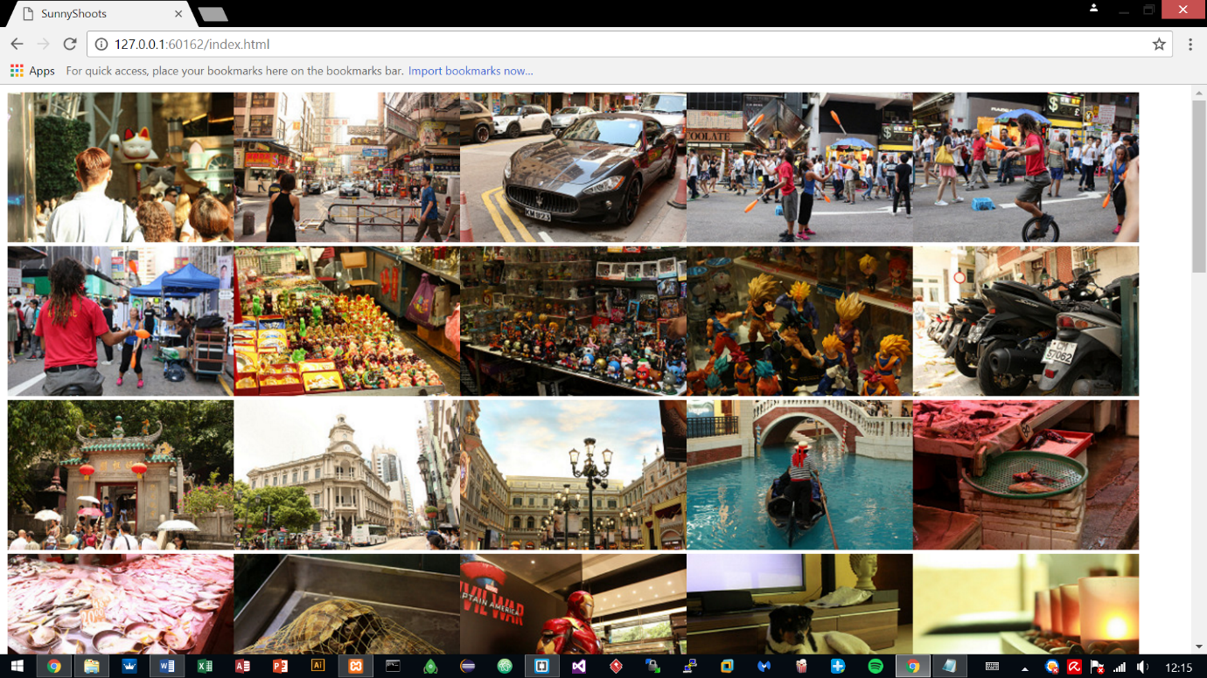

# Created Interface design

After testing the JSON formatting and having the results returned back successfully, it was time to move on to the interface design.

The website is based on a photography portfolio hence why importing the images using vanilla JavaScript JSON format was important.

The website was done in Photoshop and took 2 days to finish the interface, altogether 8 hours were put into it.

## 4.1 Sequence 1 – Index Page

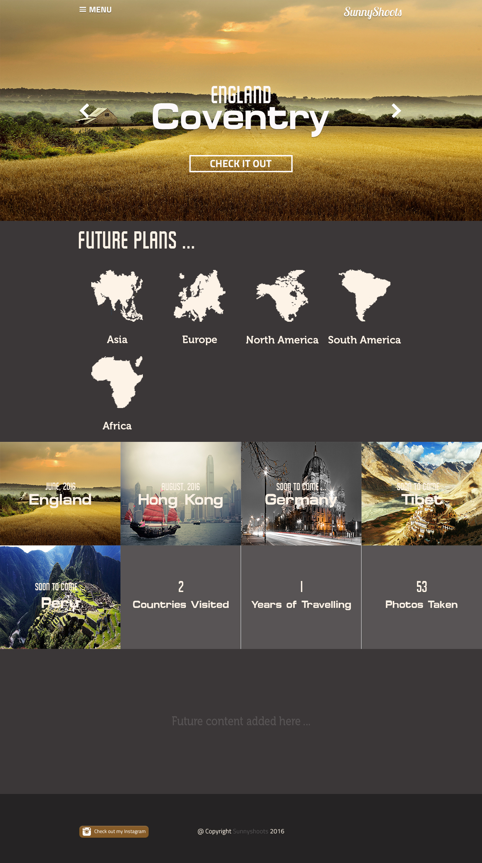

## 4.2 Sequence 2 – Opening Menu

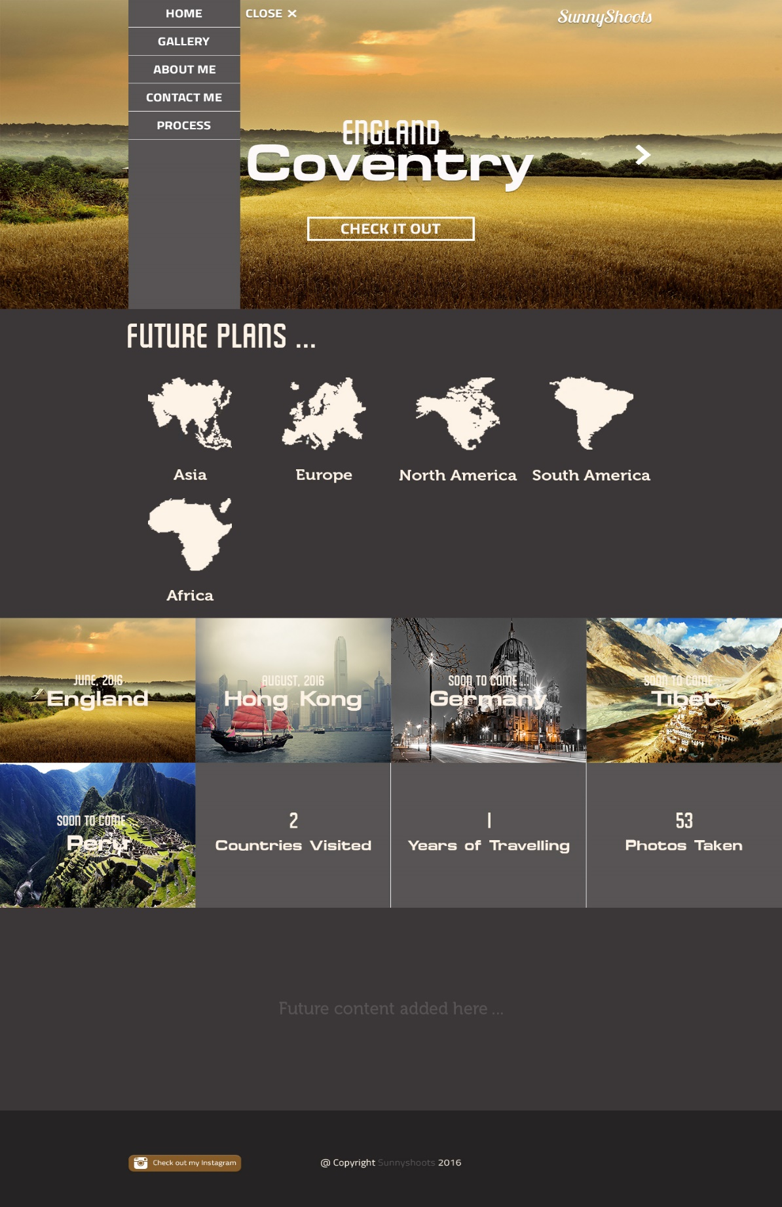

## 4.3 Sequence 3 – Gallery Tab

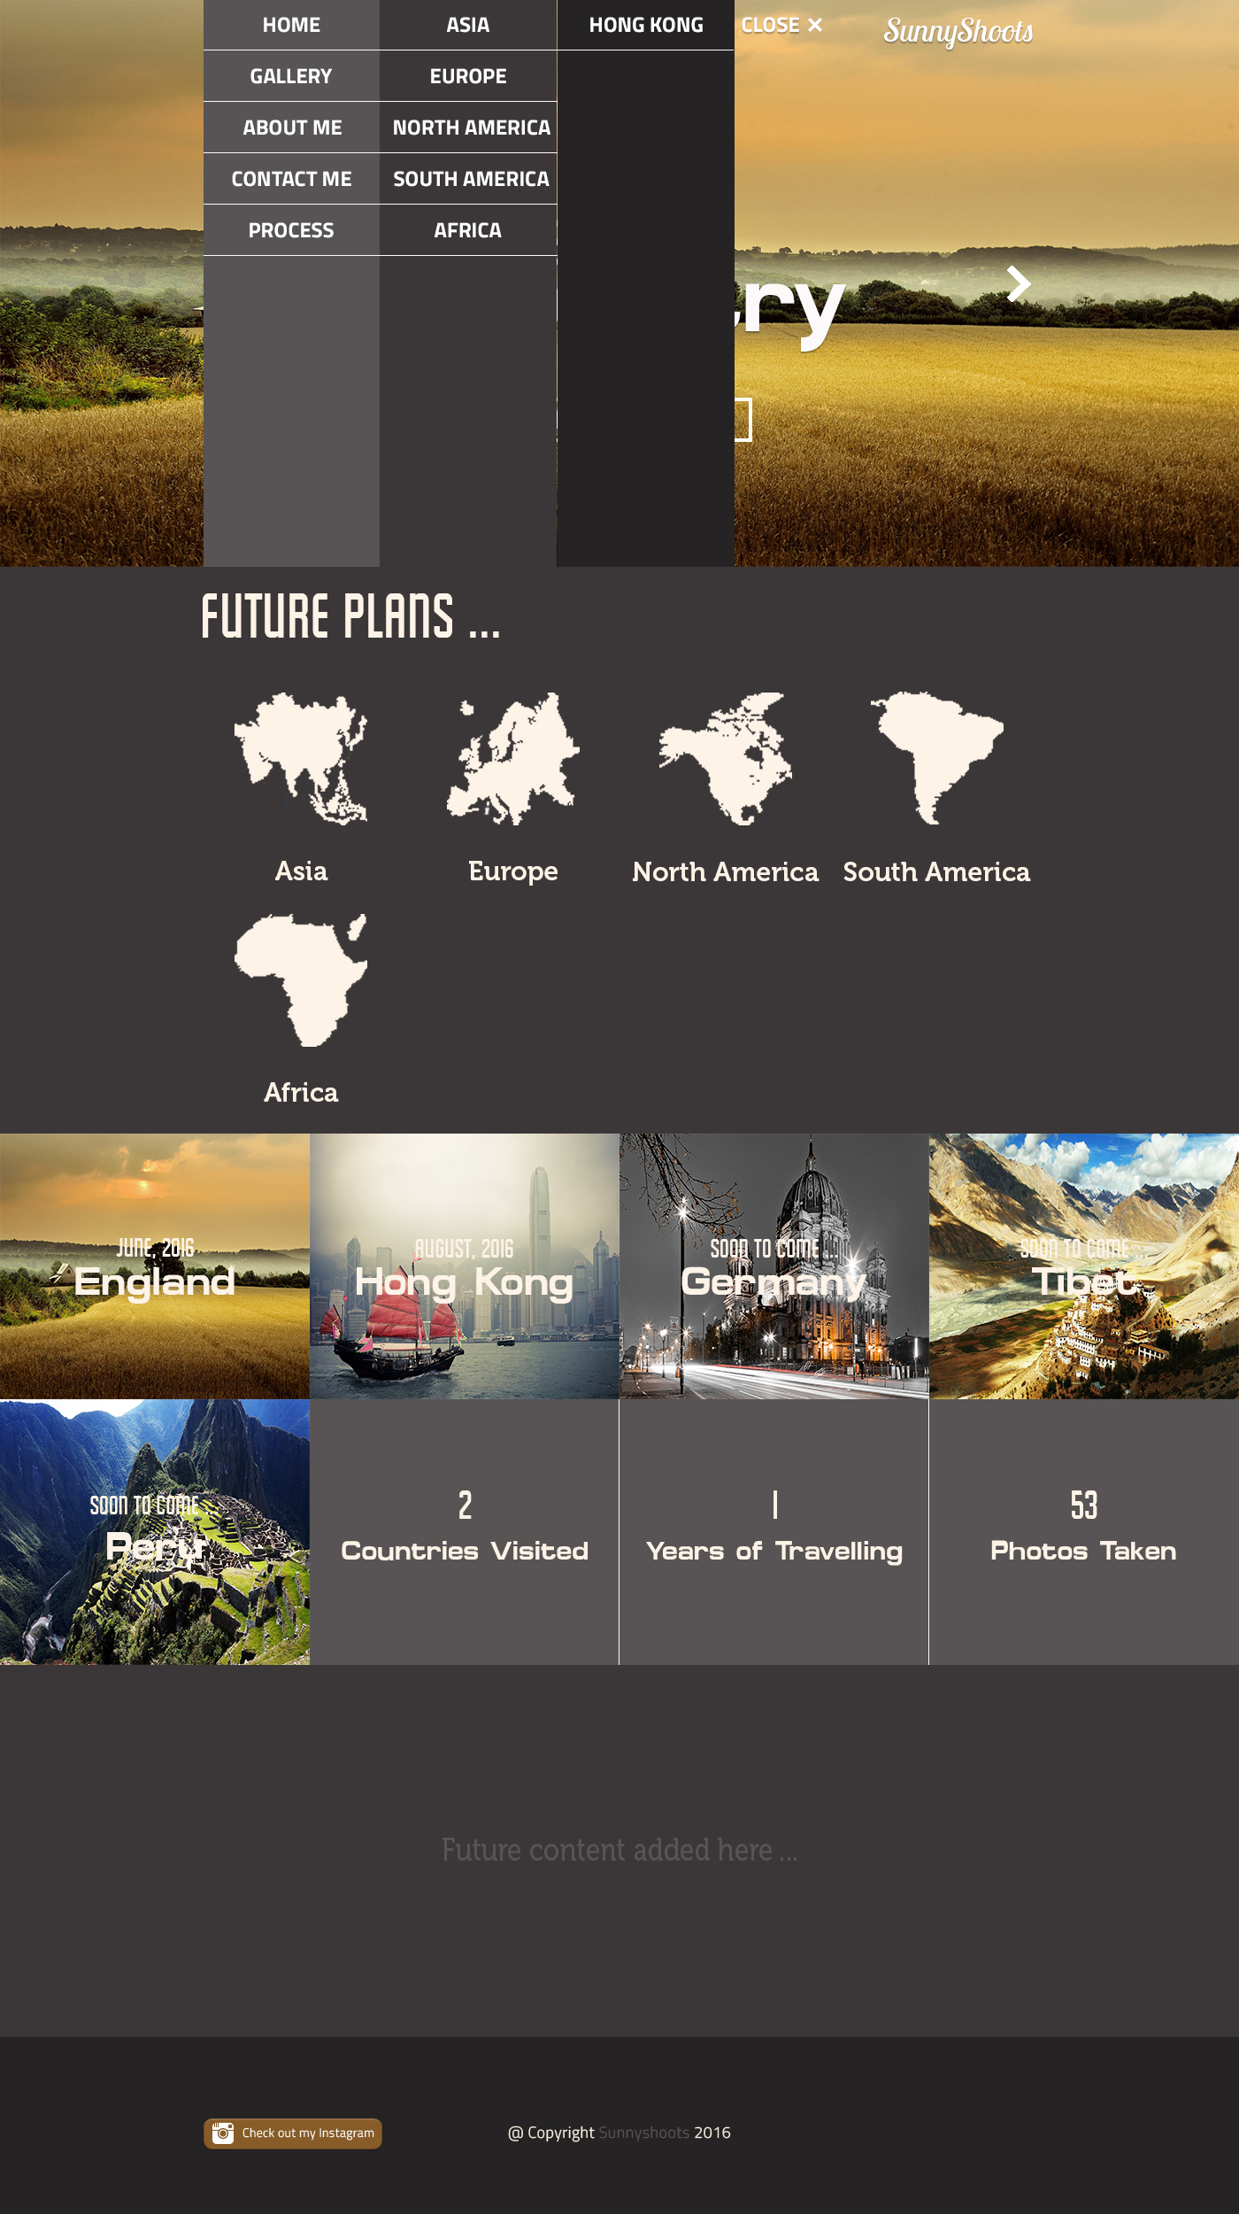

## 4.4 Sequence 4 – Gallery Page

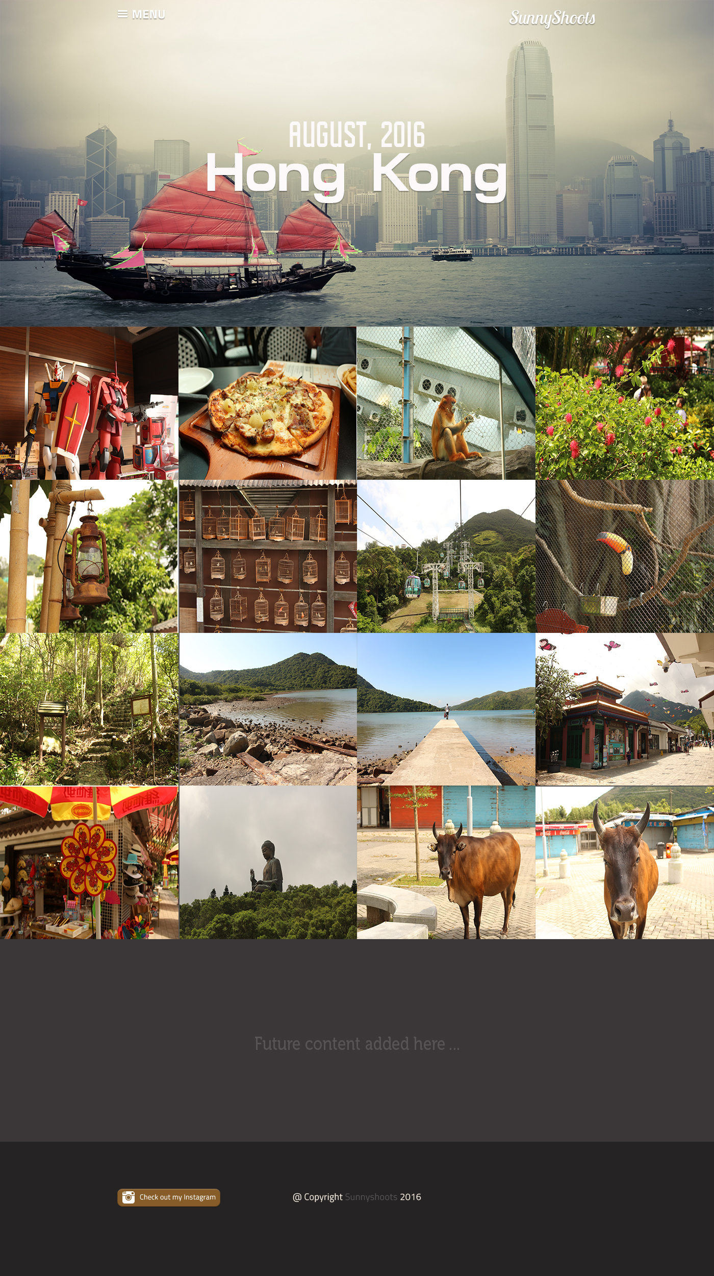

## 4.5 Sequence 5 – About Me

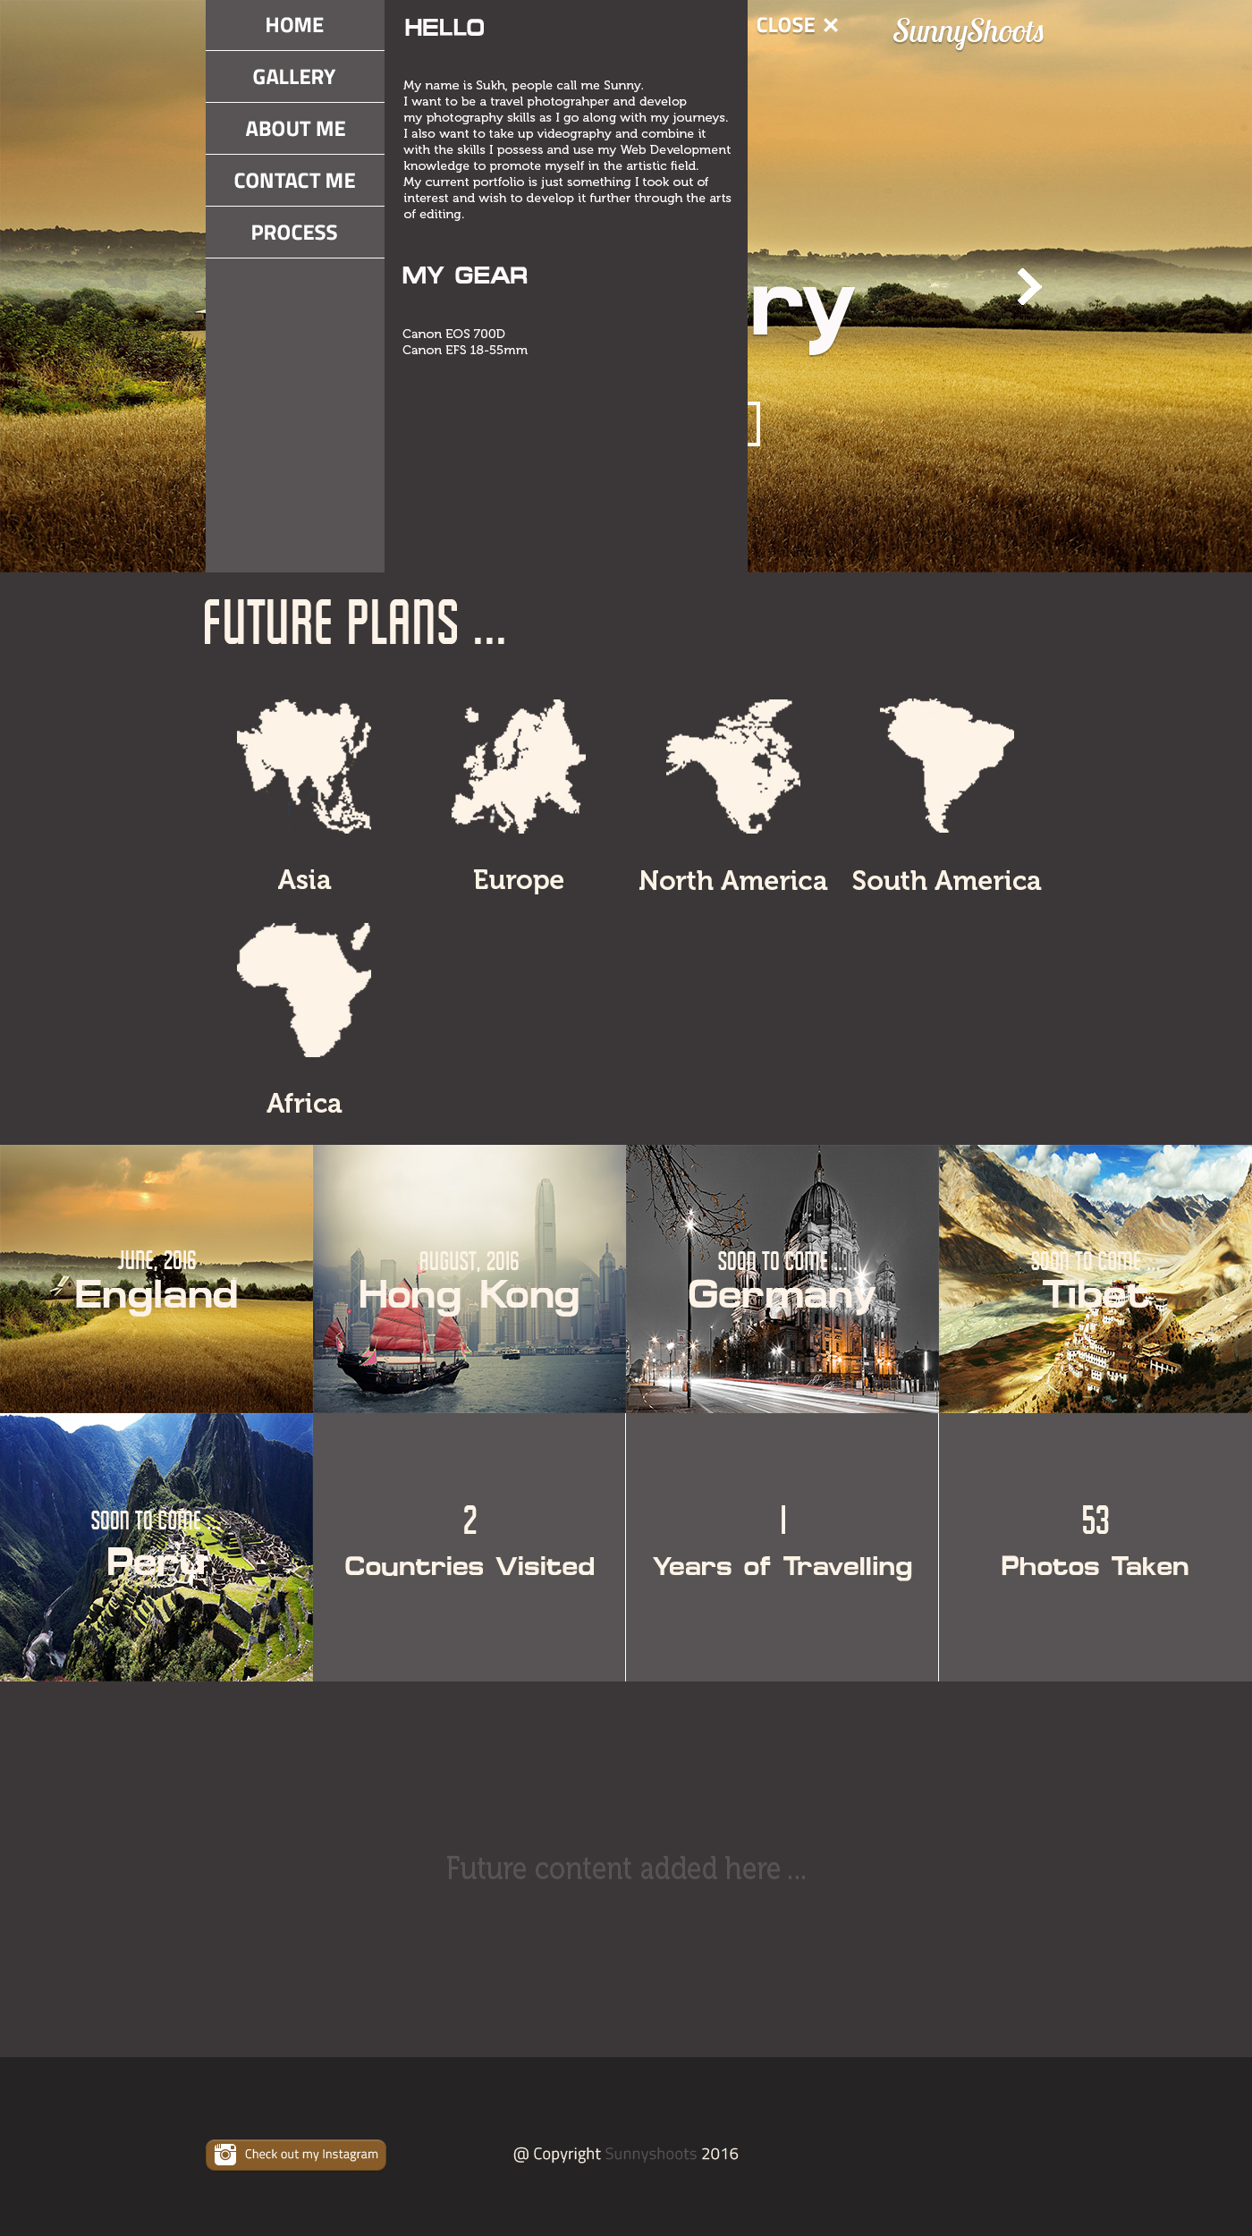

## 4.6 Sequence 6 – Contact Me

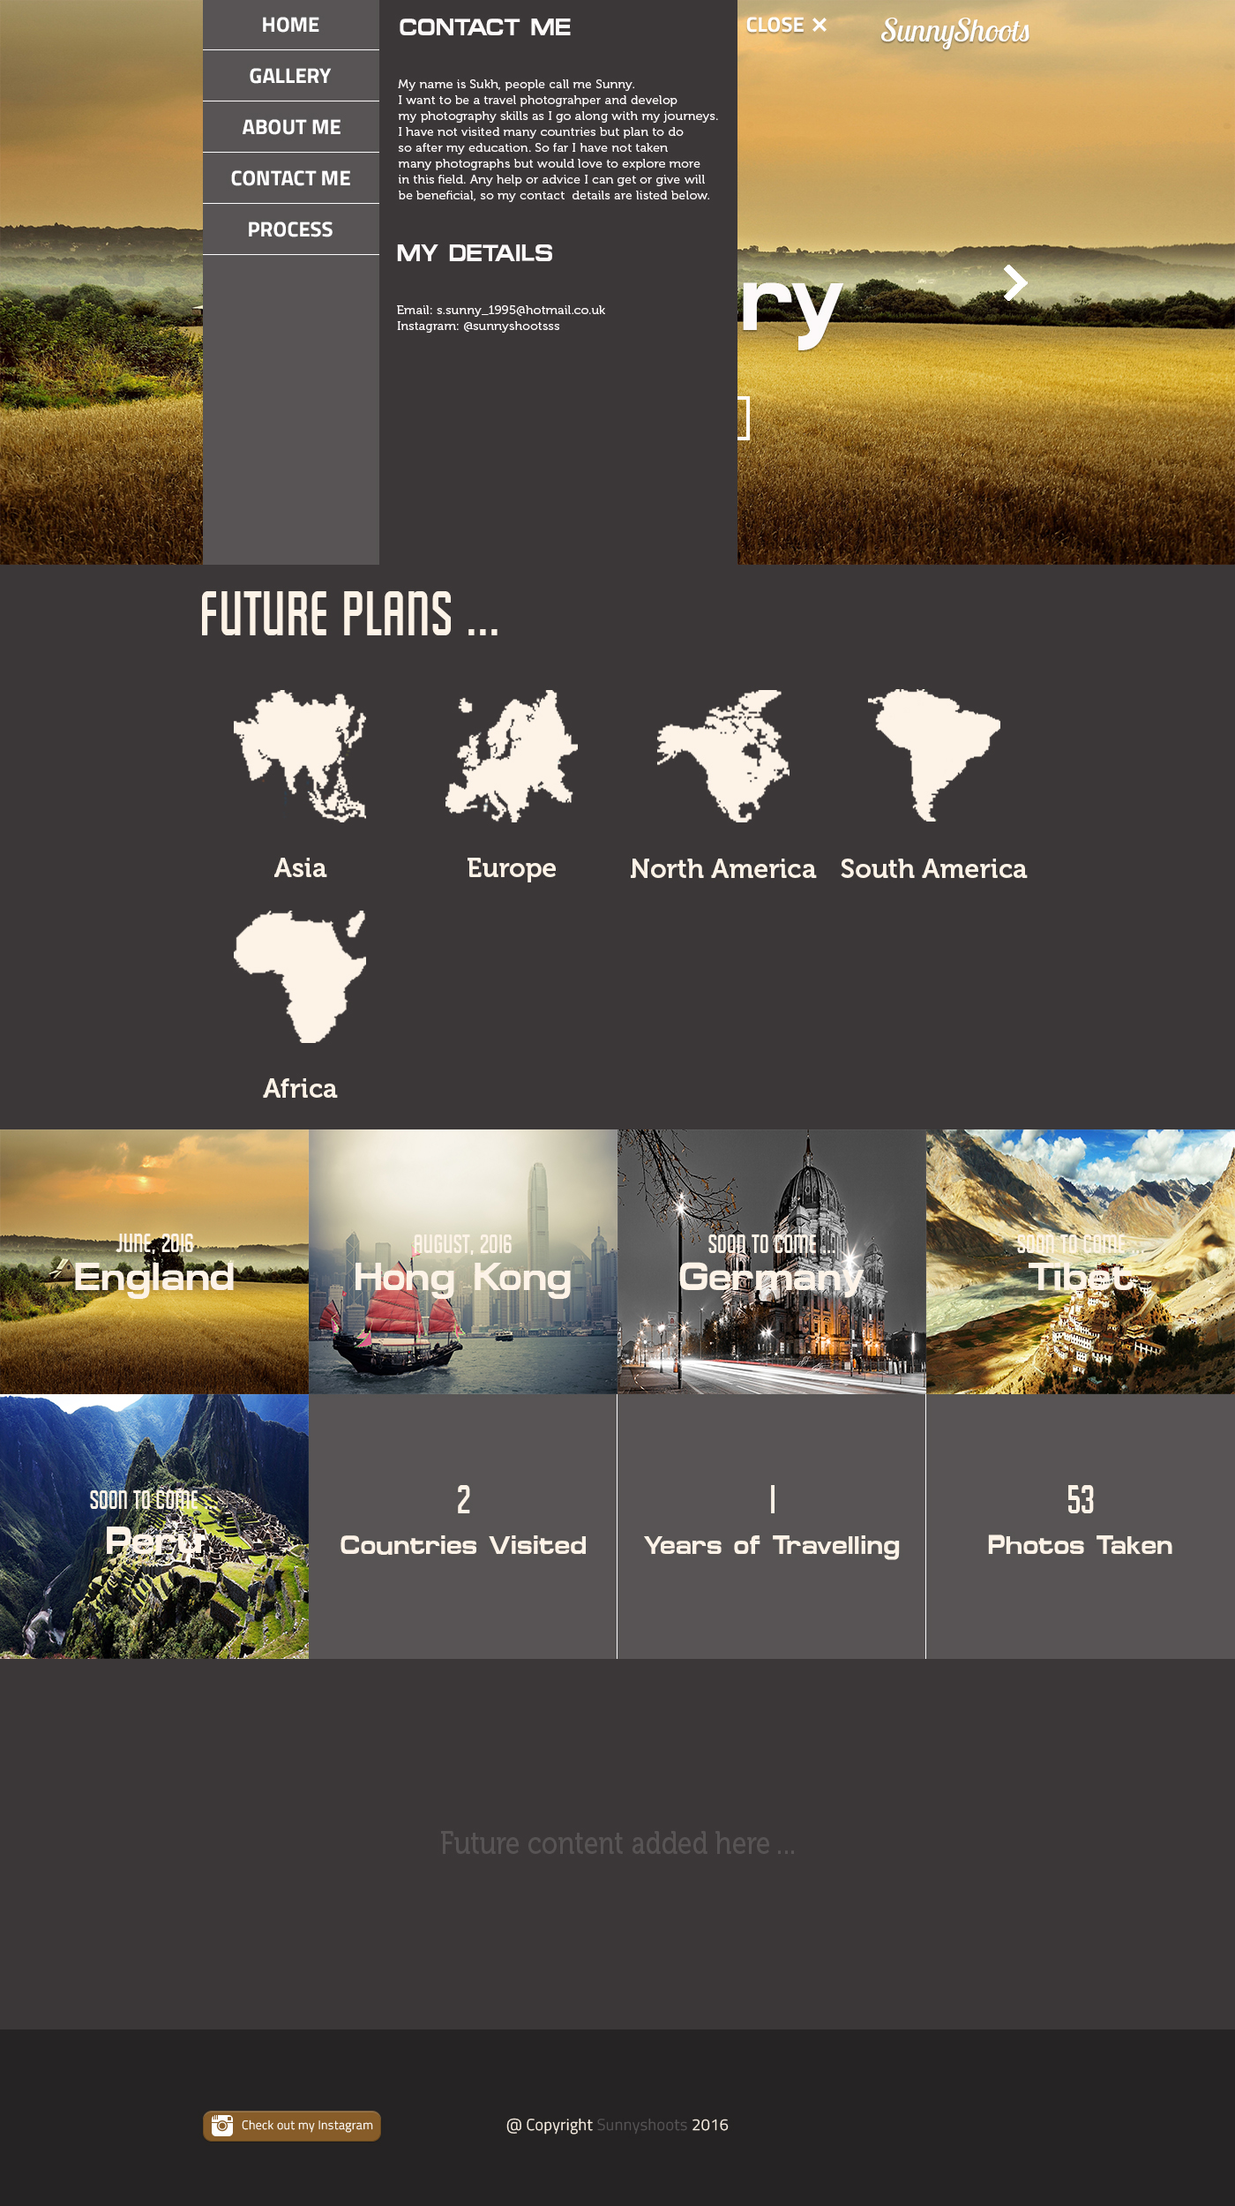

# Started working on index.html

Index.html is the page that is loaded first. There are only 3 pages altogether for this site which consists of the Home page and the 2 Gallery Pages: England Gallery and Hong Kong Gallery.

The structuring of the index.html page was done using Bootstrap for grid layout and Bootstrap is a quick framework utilized for developing the site. However, this was only used for the construction of grids and the rest of the layout representation is done manually.

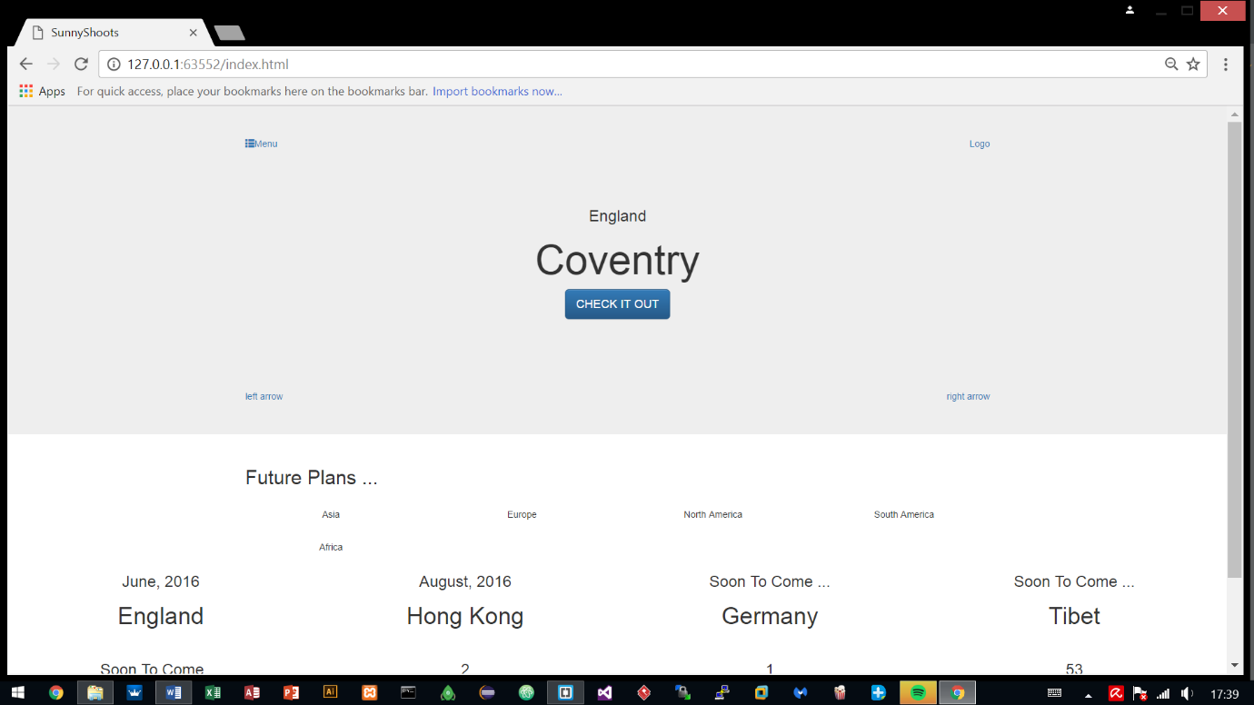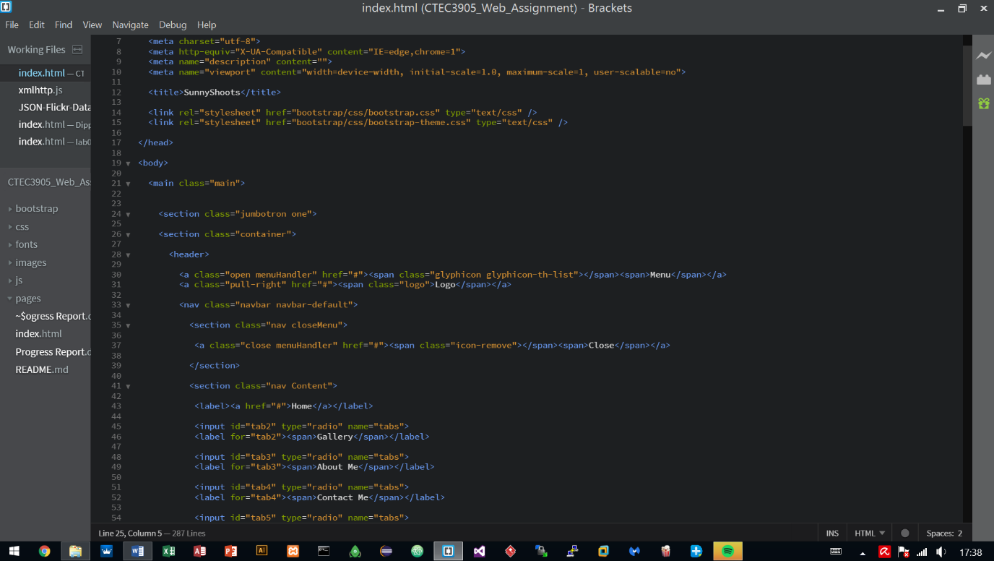The reason for using Bootstrap is because it has been utilised before in other projects and has proven to work well, providing quick results so other areas could be looked at earlier on such as using animations and JavaScript to handle parts of the site.

## 5.1 Added two more pages – hongkong.html and england.html

After working on the index.html, two more pages were added which are the gallery pages, displaying photographs of the places that were visited and the pages are titled according to the countries/cities visited.

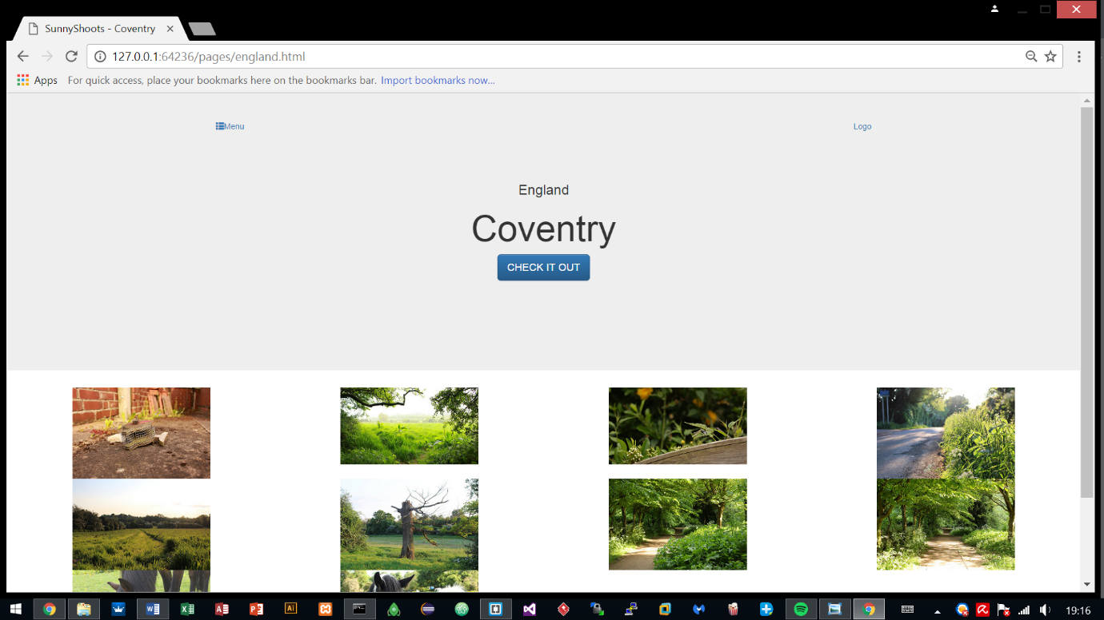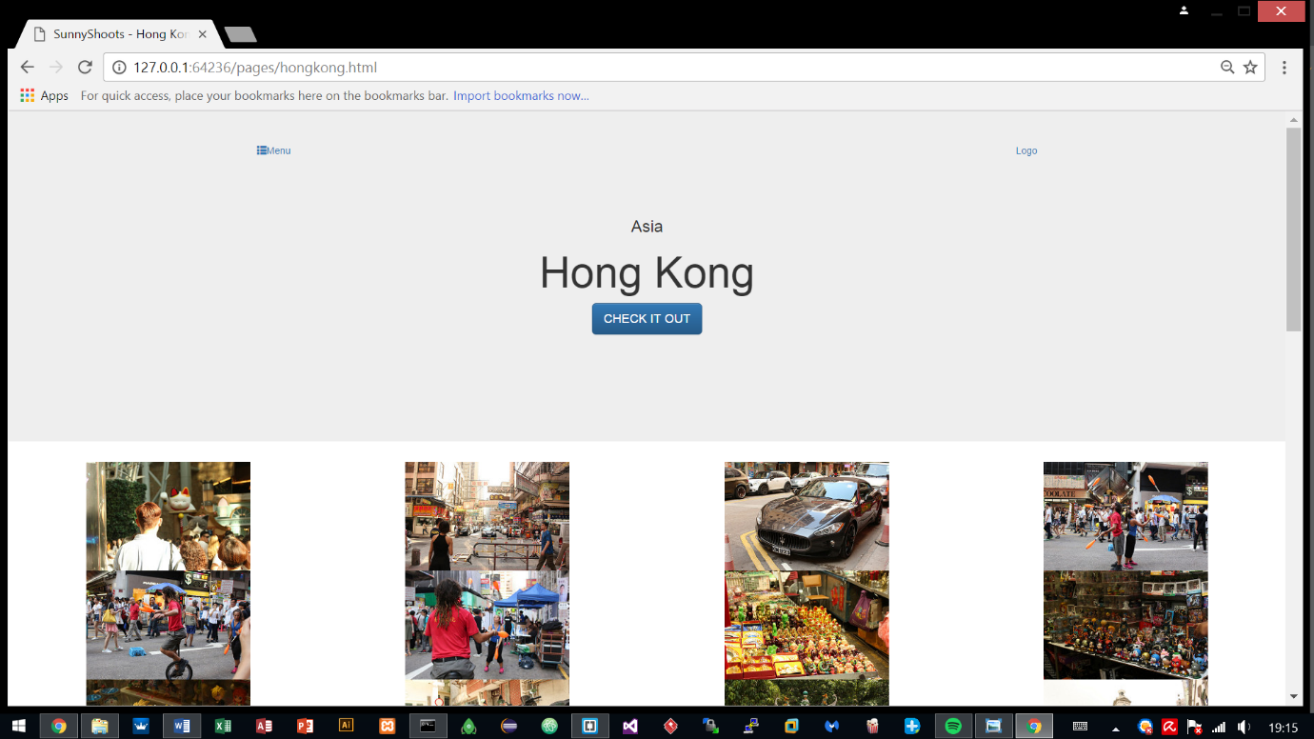The syntax for both pages have a similar layout in contrast with the index.html so most of it was just copied towards these html files and was edited. The two pages share the exact same syntax, only required changing of the class names.

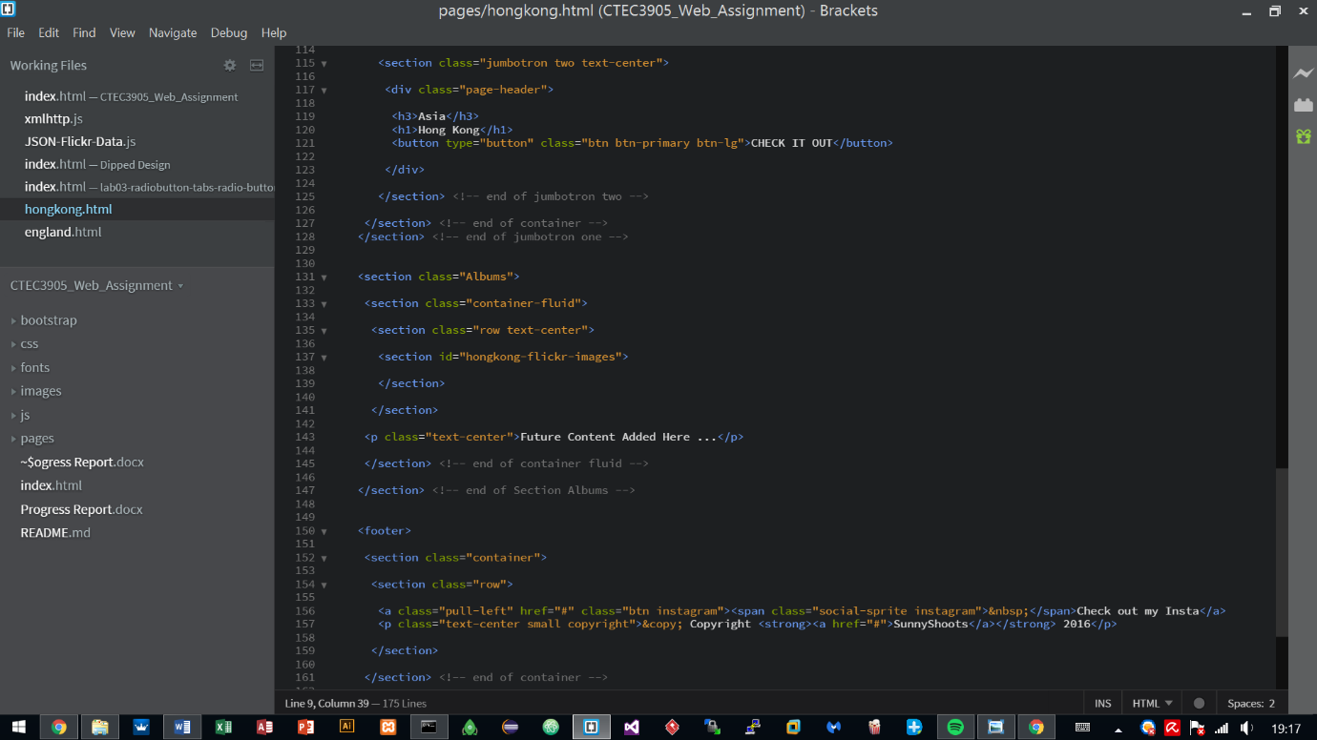

# Styling

Styling started and has been done on the 1st and 2nd sections during the earlier stages of the site, other parts were still in progress.

The fonts and logos were initialised to what the interface designs showed and at that stage it was majorly focused on finishing off the style so other areas such animations and JavaScript, could be looked into.

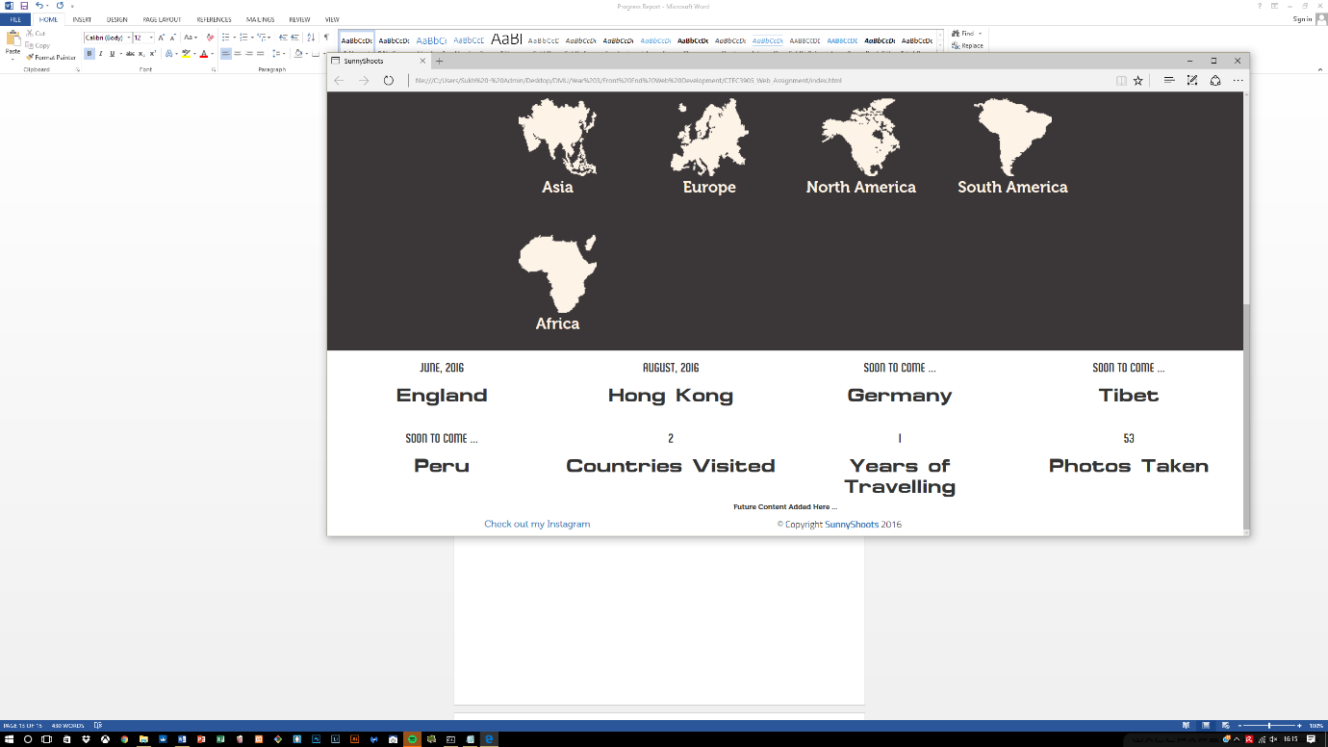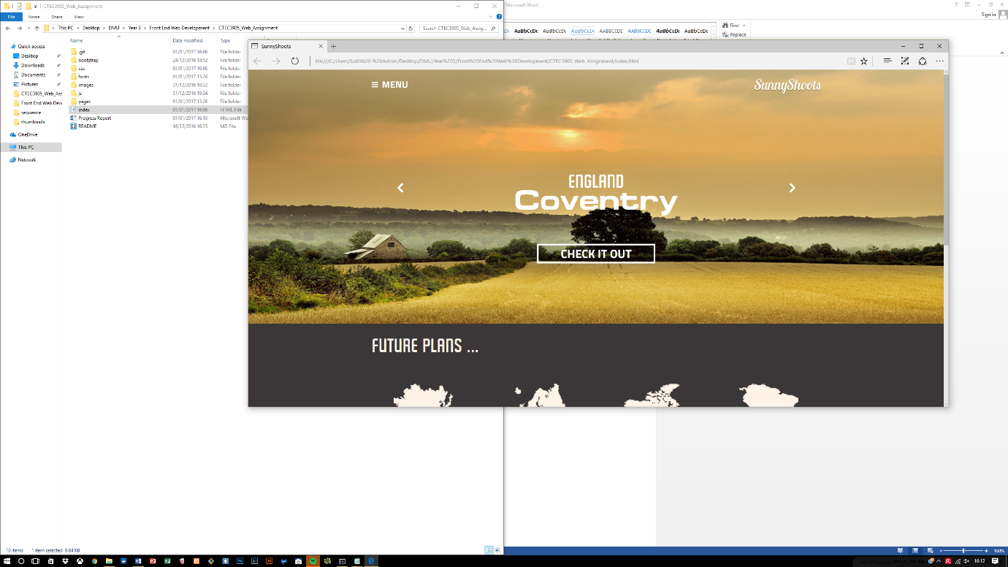

Two CSS stylesheets are being utilized, the rest is what Bootstrap provides by default. All styling has been done manually, Bootstrap, as said previously only provided a means to create grid layouts to quickly dive into other areas.

***Font.css*** sets up the font families that can be utilized within the development of the site and the ***style.css*** works by changing what bootstrap provides to suit to the interface design.

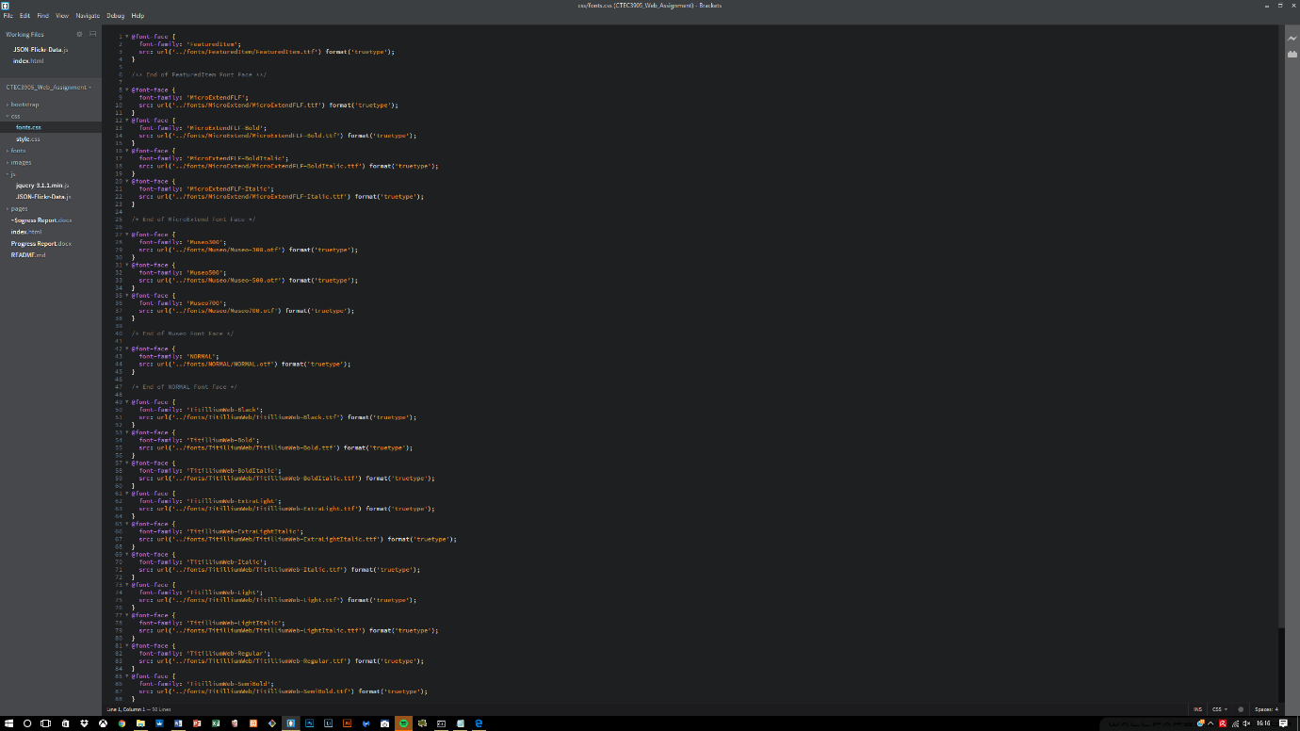

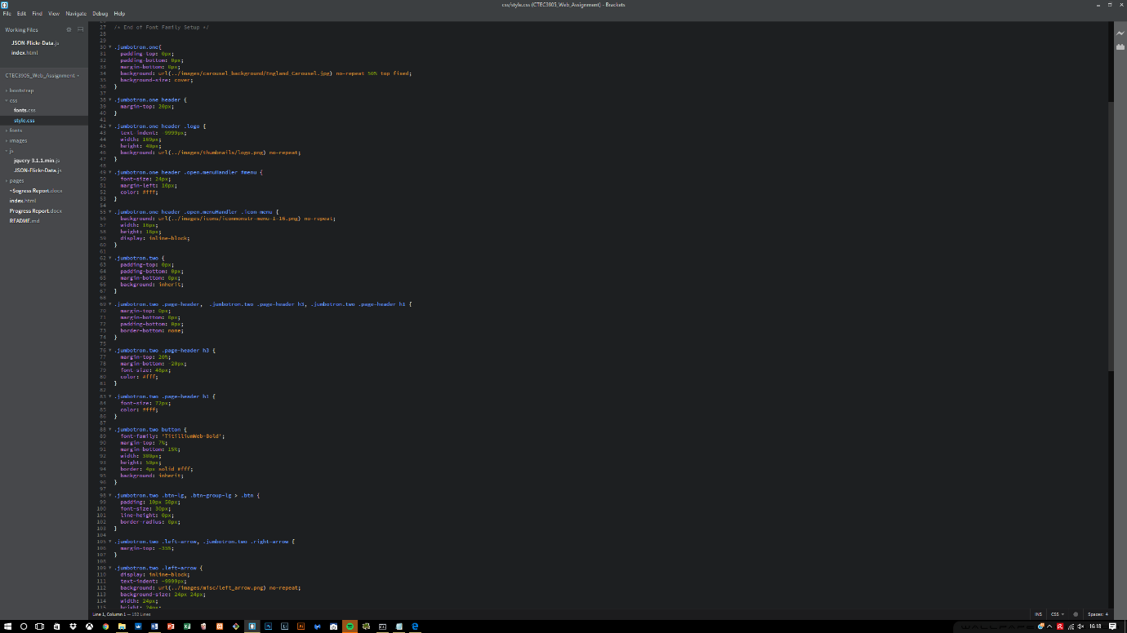

## Errors encountered within the first section

During the development, an early realisation was made on the structure of the semantics which was not correct. The menu header was inside a container which held other main containers which should not have been there.

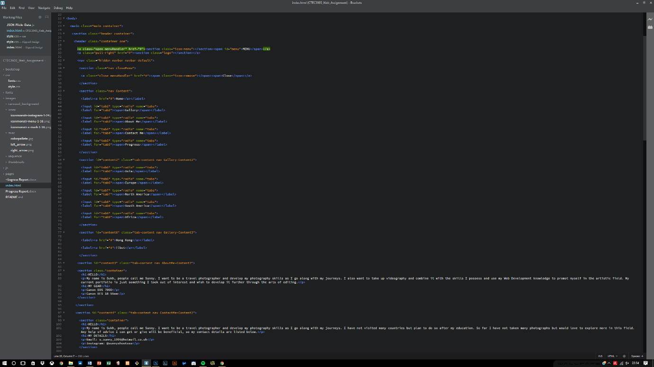Therefore the entire process took a lot of time due to rearranging of the structure and now the structure is working fine, the menu header is fixed and separated from the other content within the container. There is now the main container holding the entire site, and different containers holding relevant content.

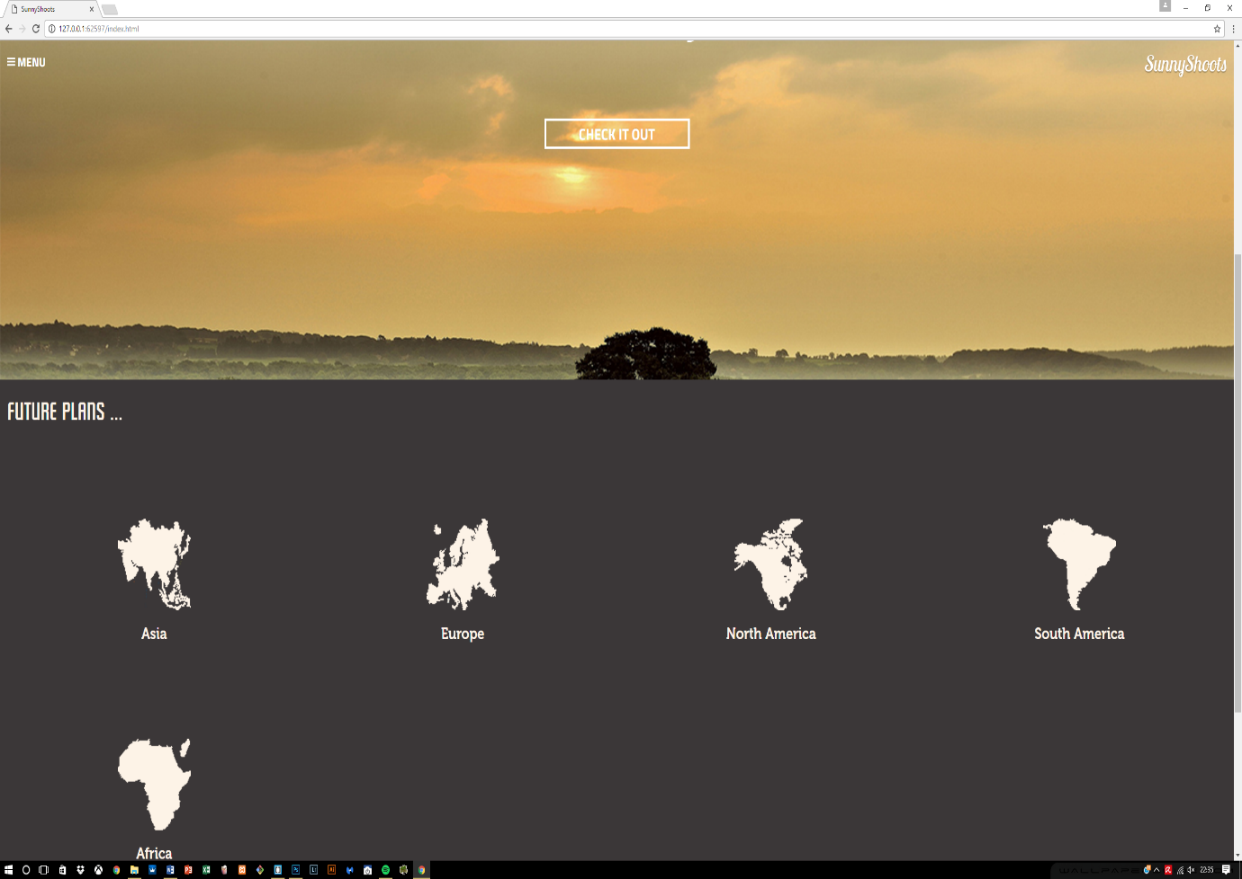

## 6.2 Progress made after the errors

After the first encounter with the errors, it was daunting to correct the mistakes and had to make sure the structure was correct which took up a lot of valuable time but on the contrary, the design aspect finally came to an end. The website was developed according to the interface and all the pages show the correct results.

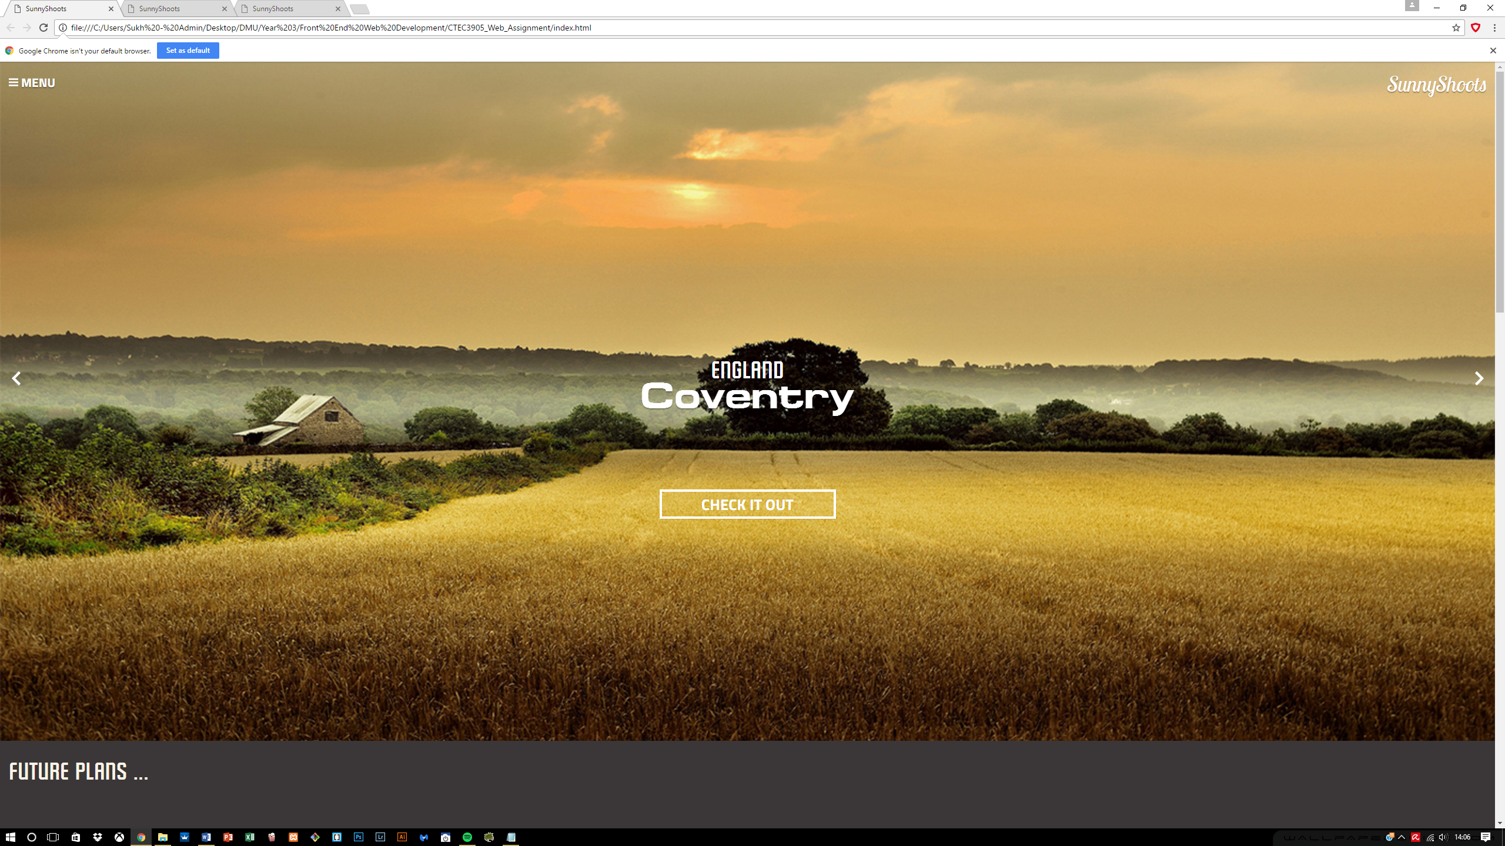

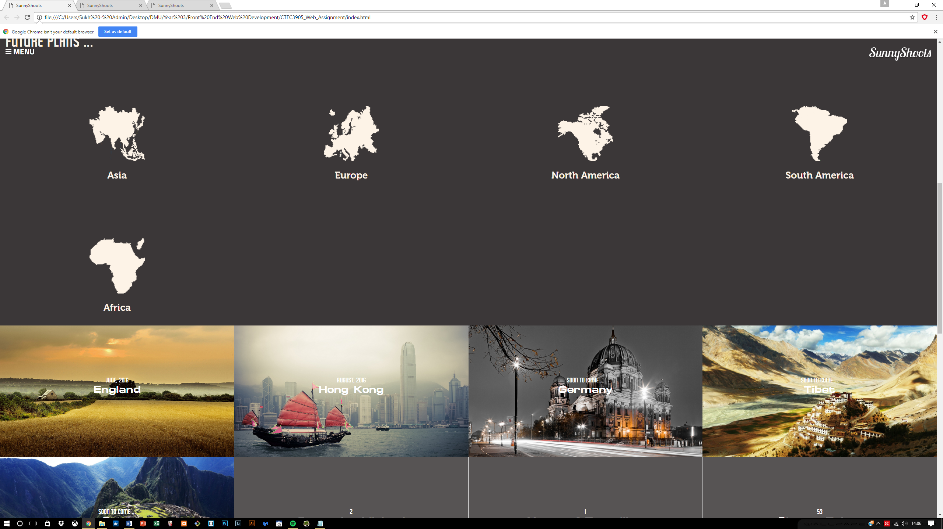

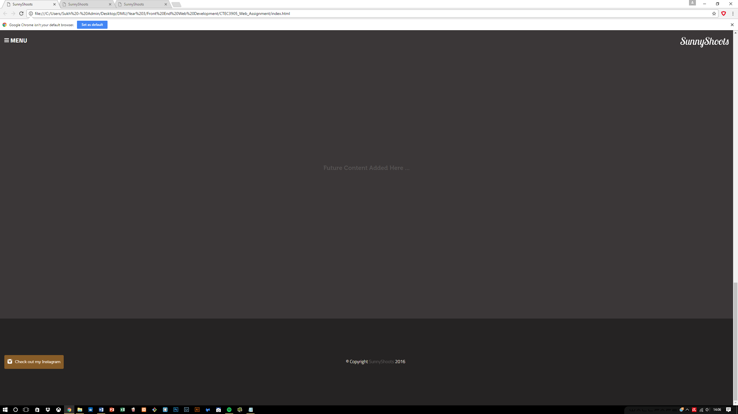

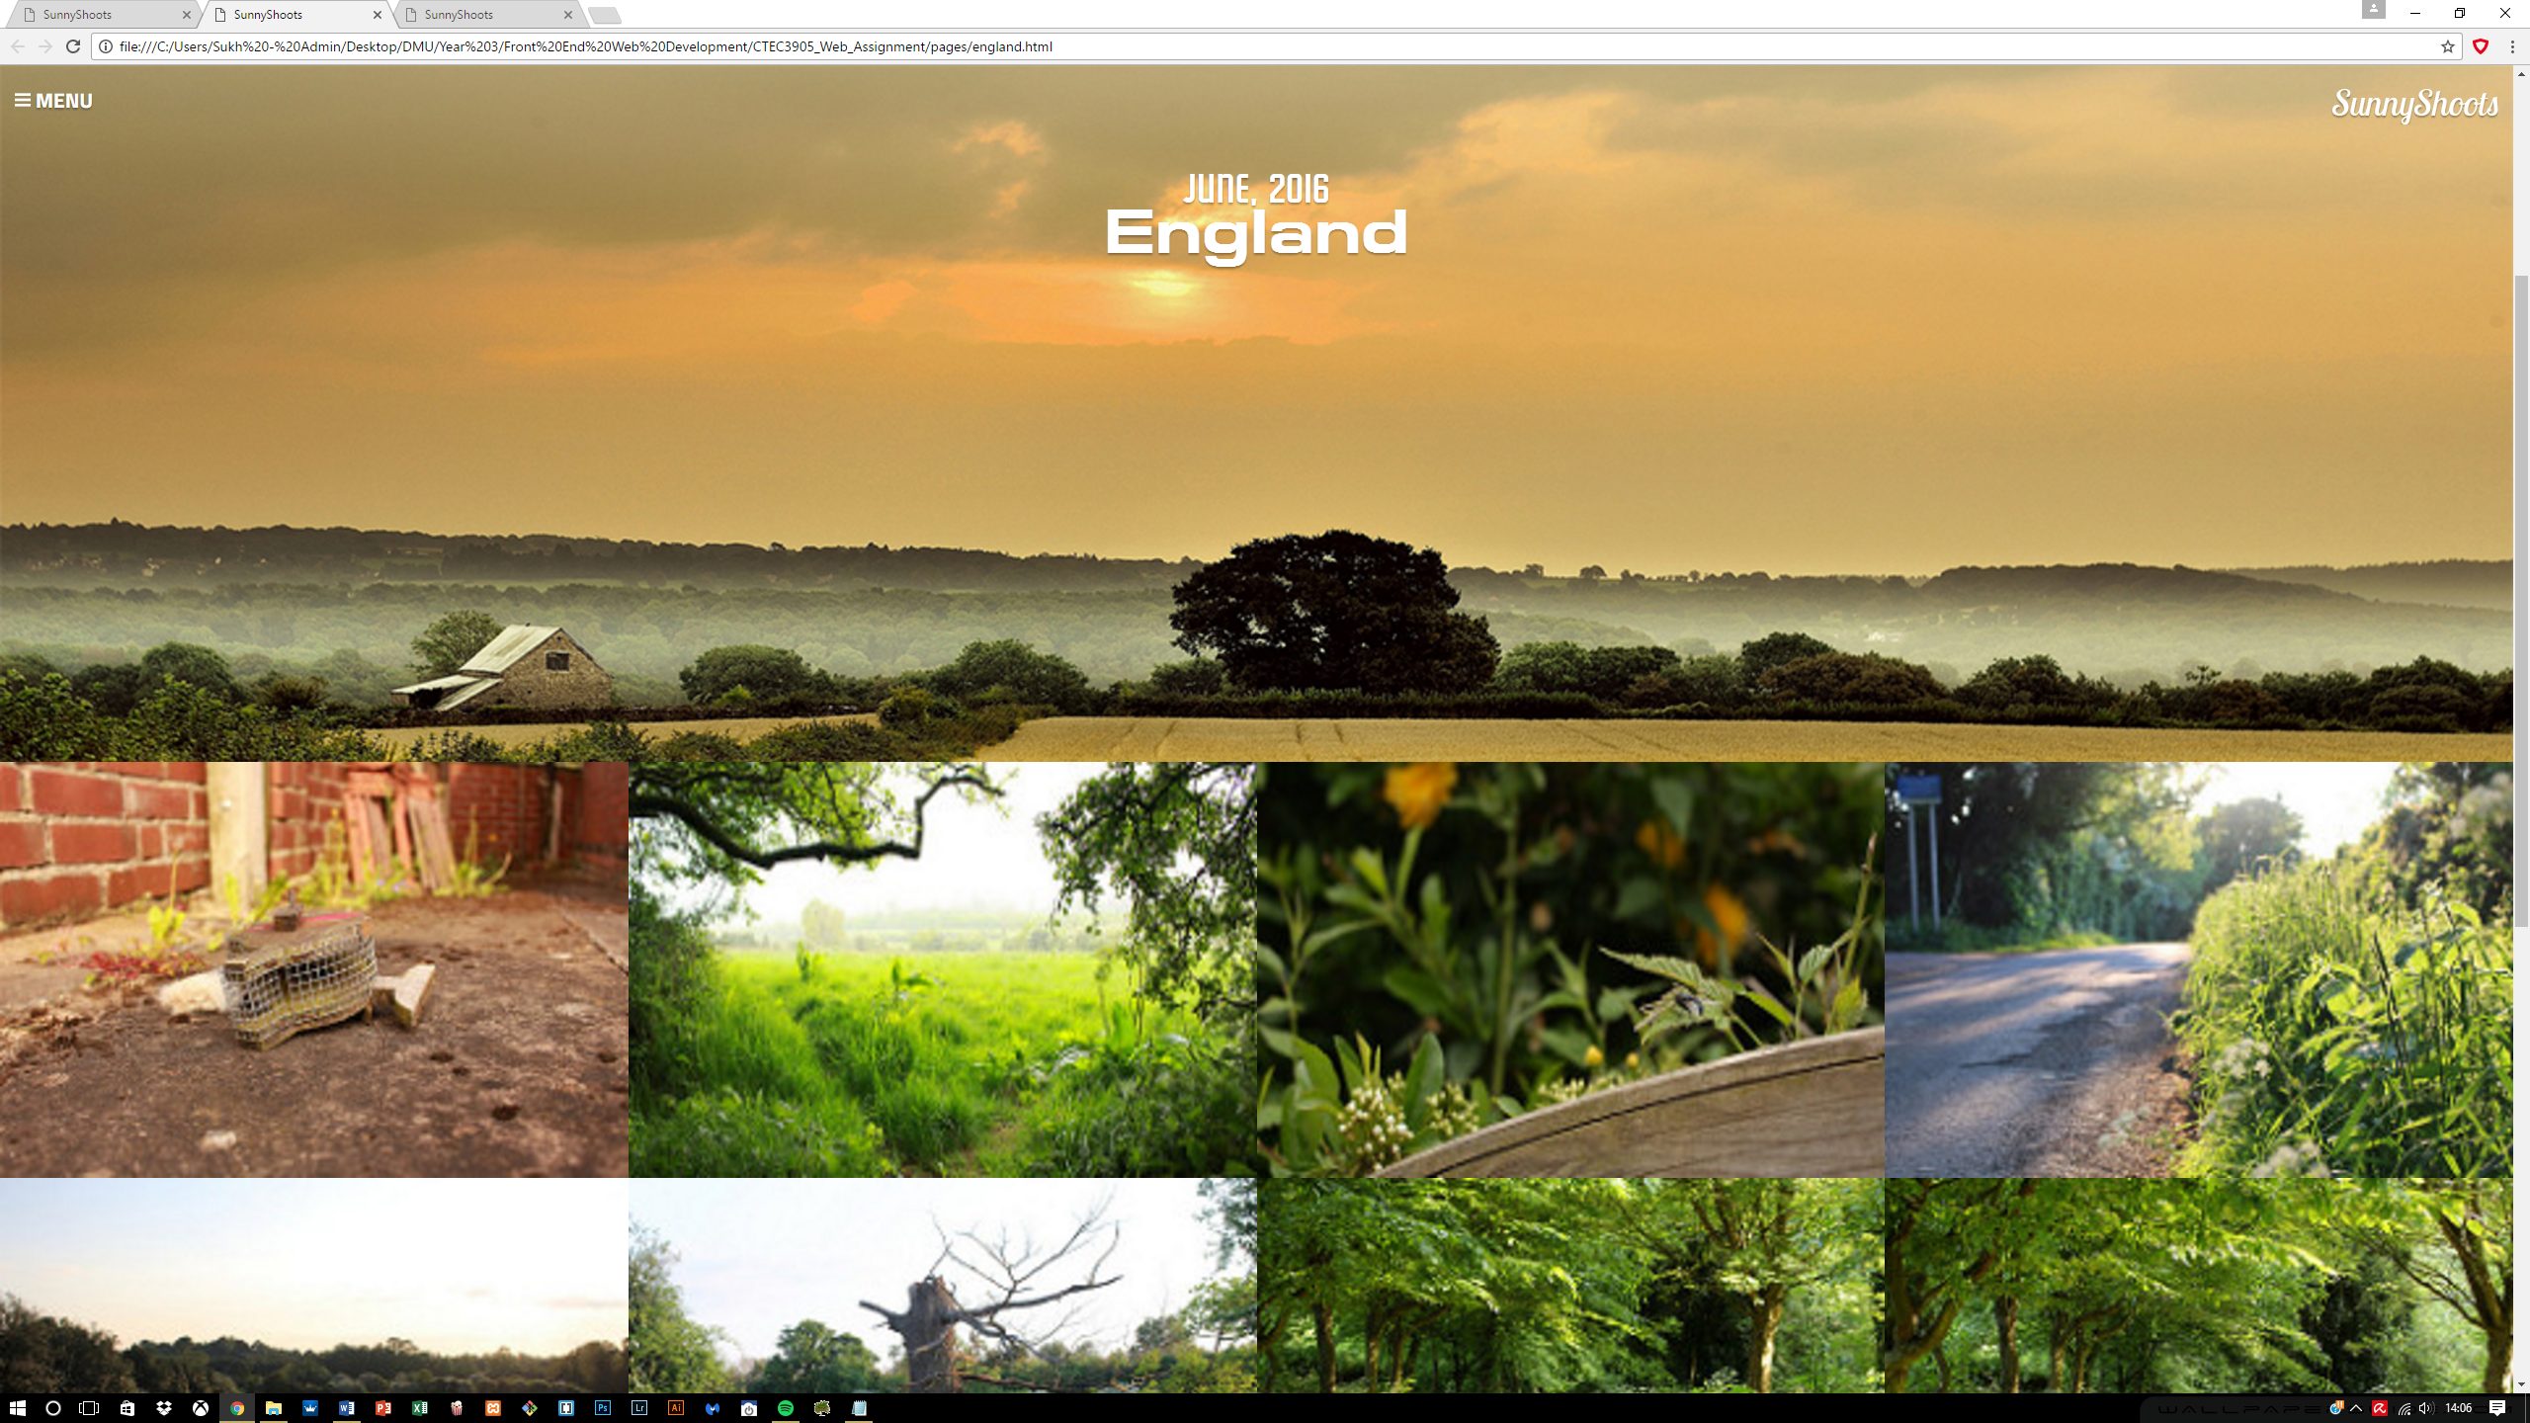

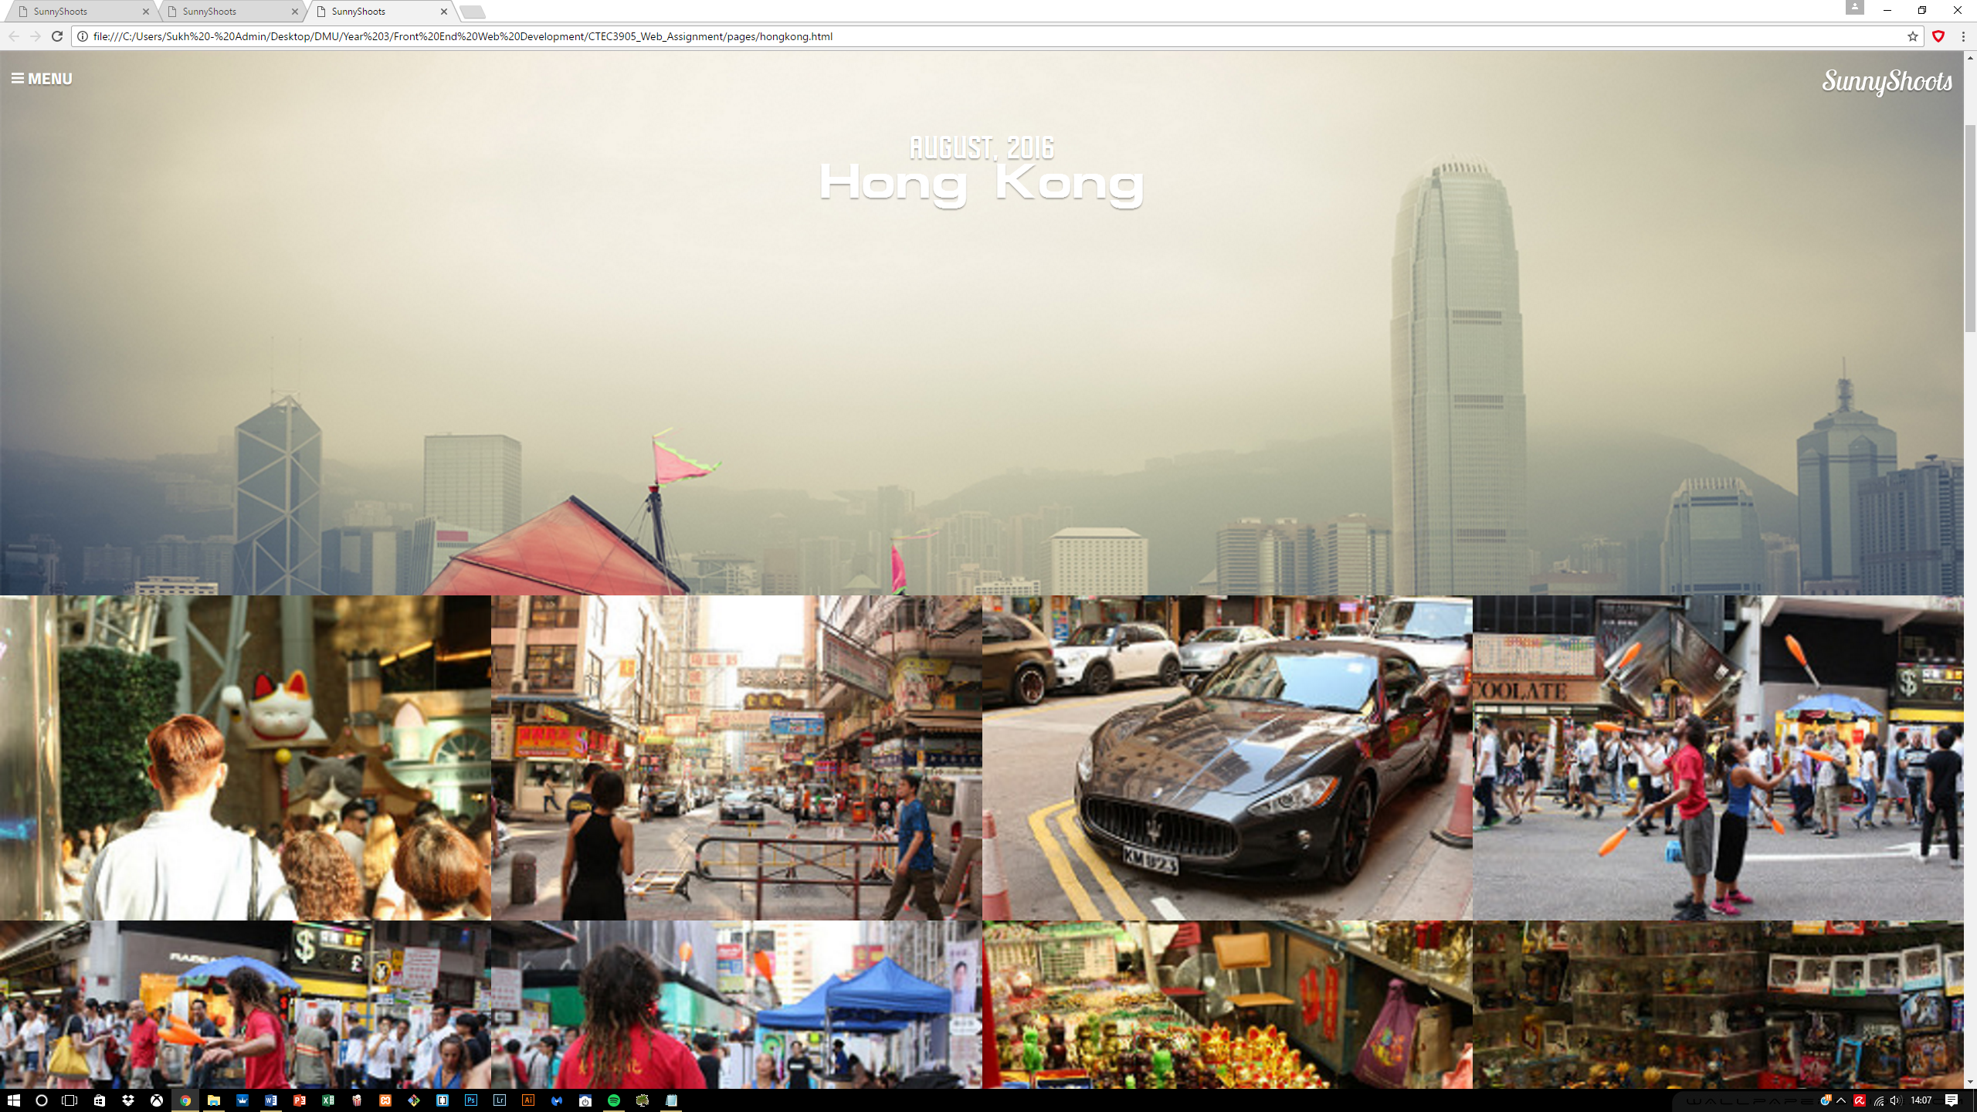

Now the focus was needed on completing the responsive side of this website, so that everything conforms to a standard.

Overall the styling did not come across as hard but it really depended on the HTML structure if any progress was needed to be made and with the help of flexbox I was able to create the images in a wrapped format so they all align on the left as more images are added.

## 6.3 Menu creation

The menu took a while to do due to the complexity involved which required developing it in an entirely new way using radio buttons. It required inputs and labels learnt from one of the University web development lab sessions and in that it suggests using radio buttons as the navigation panel. These radio buttons are hidden and controlled by the labels which act as buttons and in return we get what’s shown below.

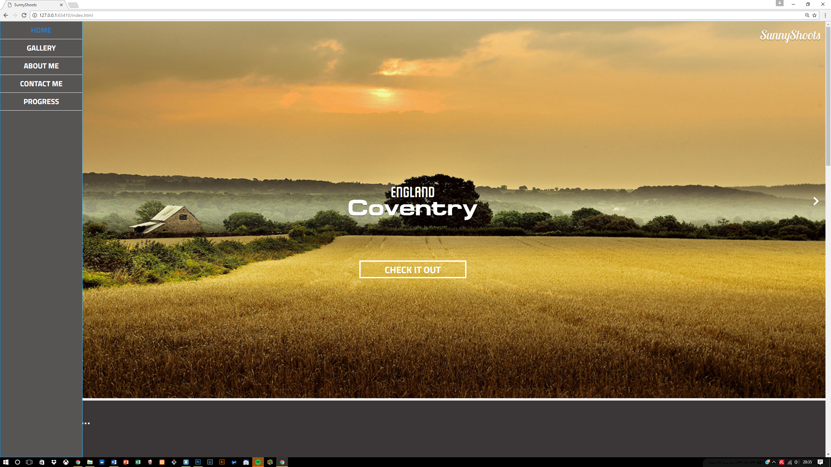

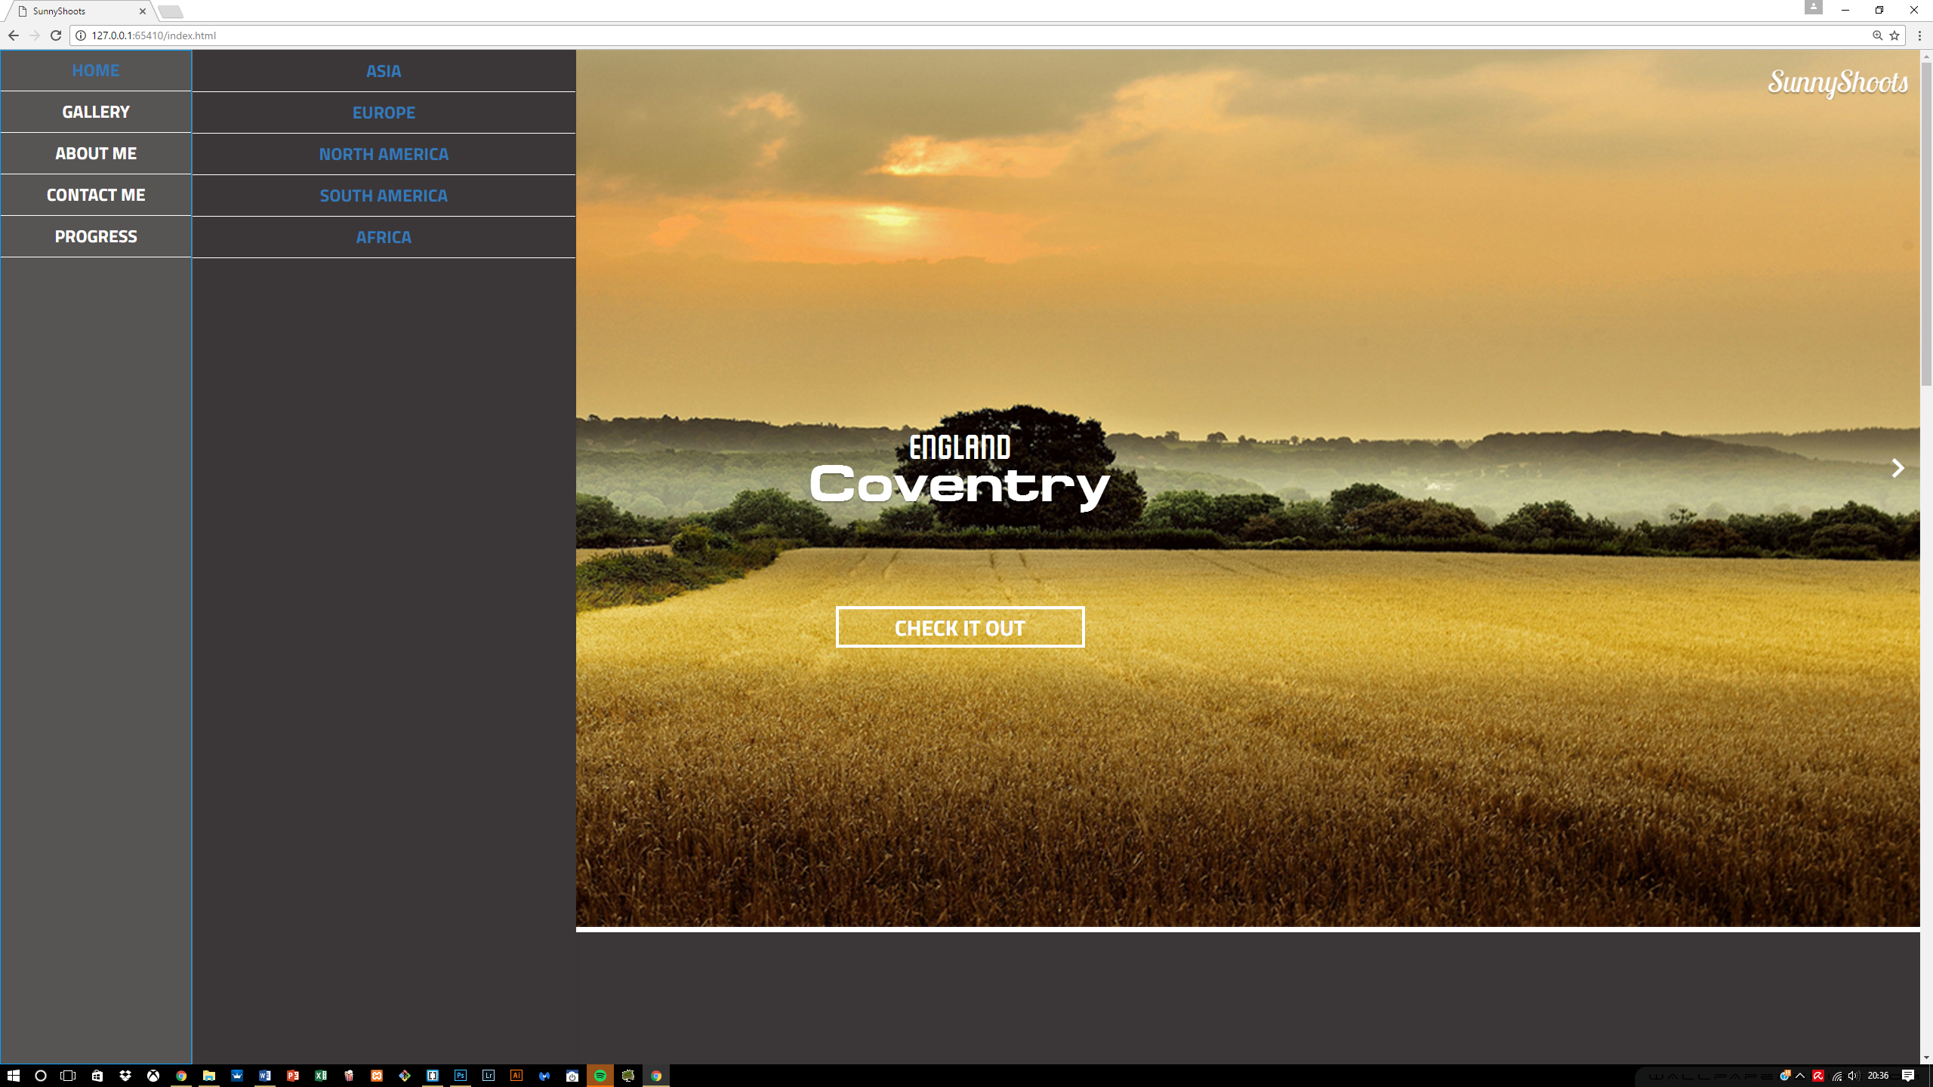

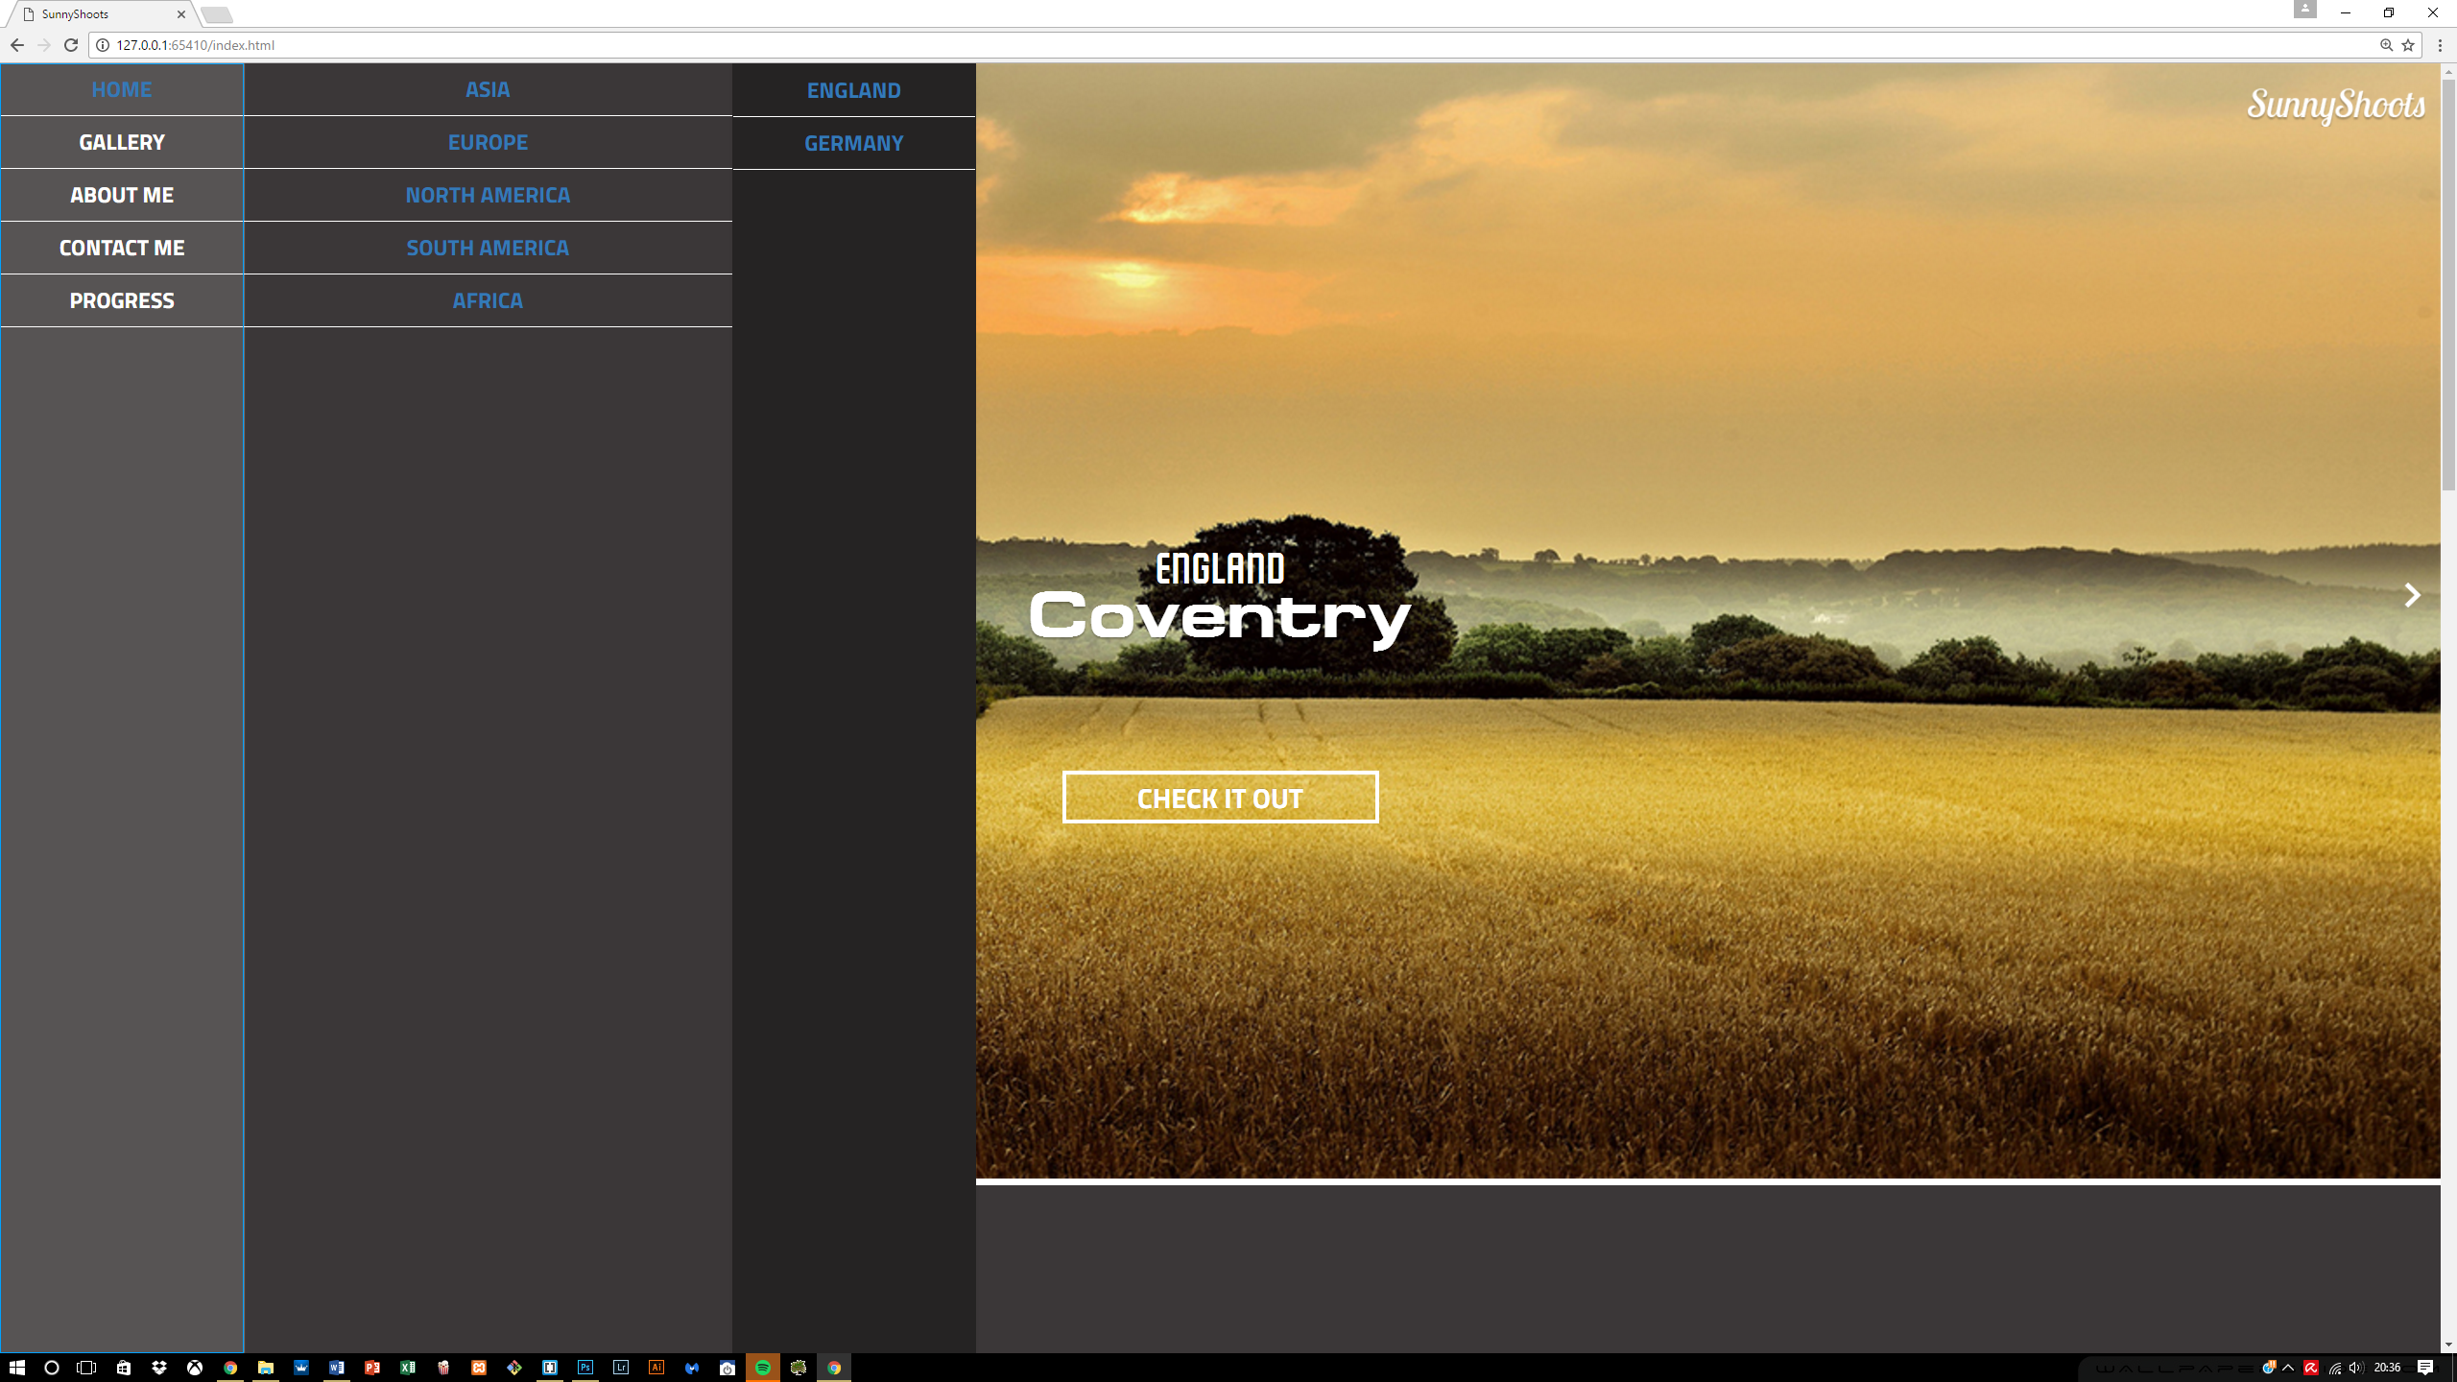

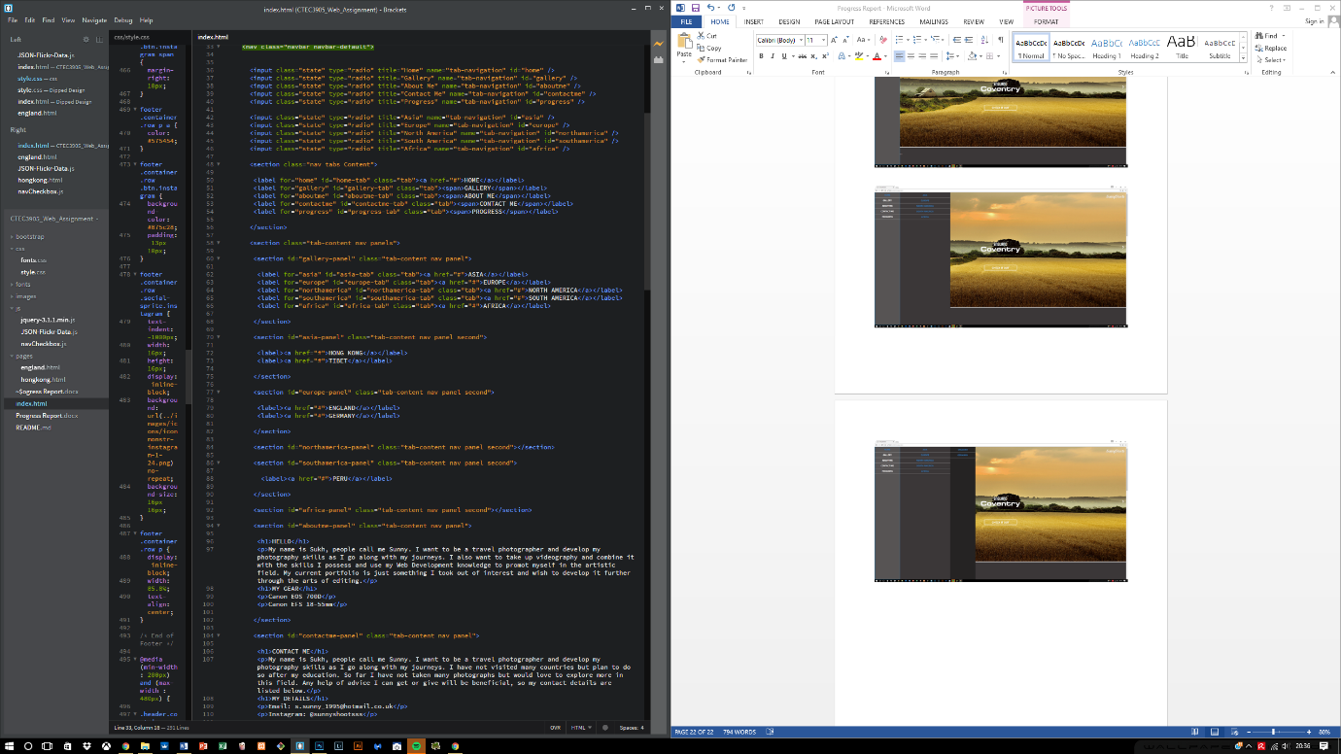

## 6.4 Responsive side of the site

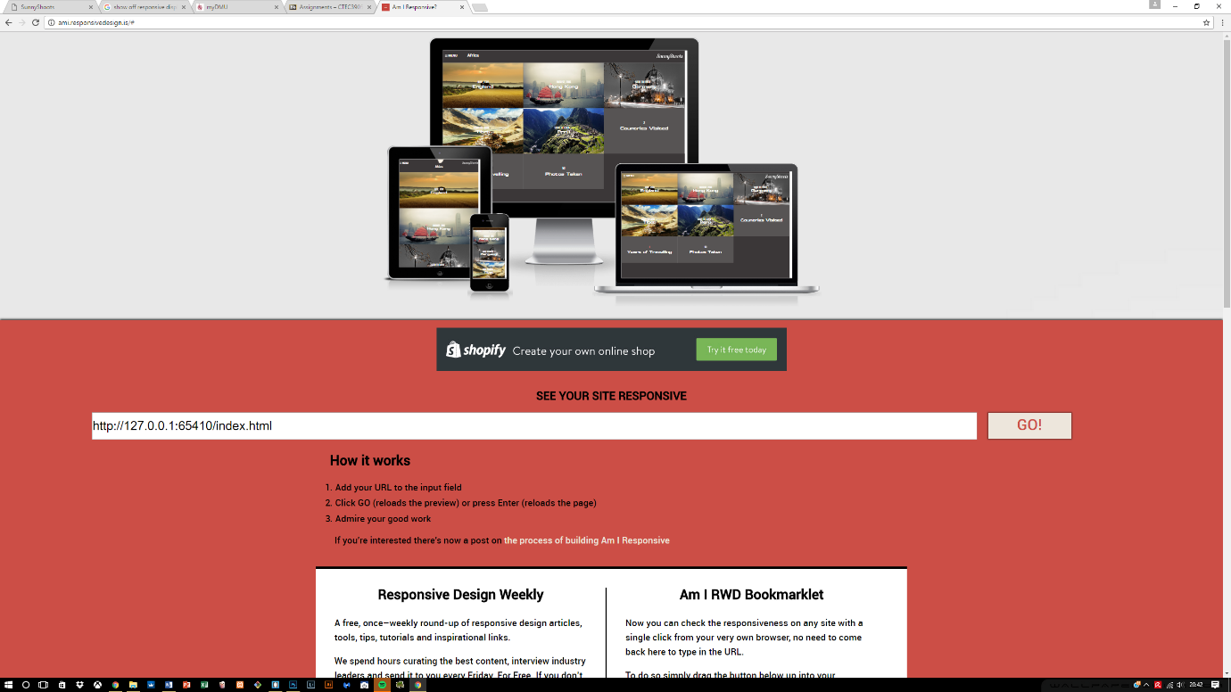After the menu creation, I started working on the responsive aspect of the website which required 4 breakpoints altogether, each of which ranges from the small to the largest device and works perfectly well.

## 6.5 Info content moved from Albums content

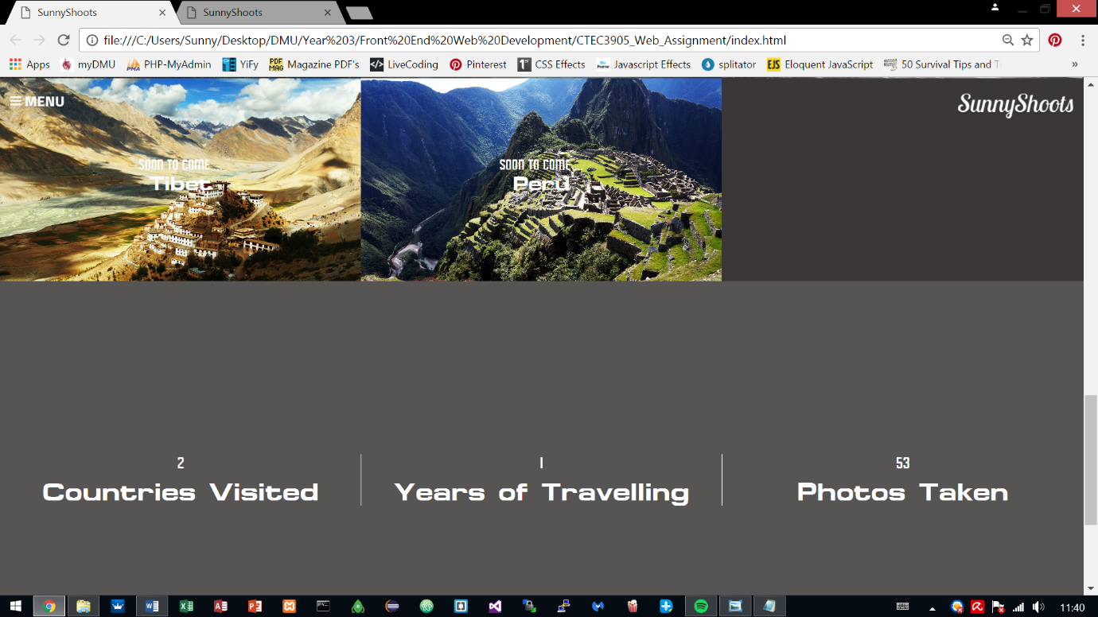The previous information from the Albums content has been moved into its own section which complies with one of the rules in PARC which is contrast and now looks much better when it is separated.

## 6.7 Navigation Bar responsive

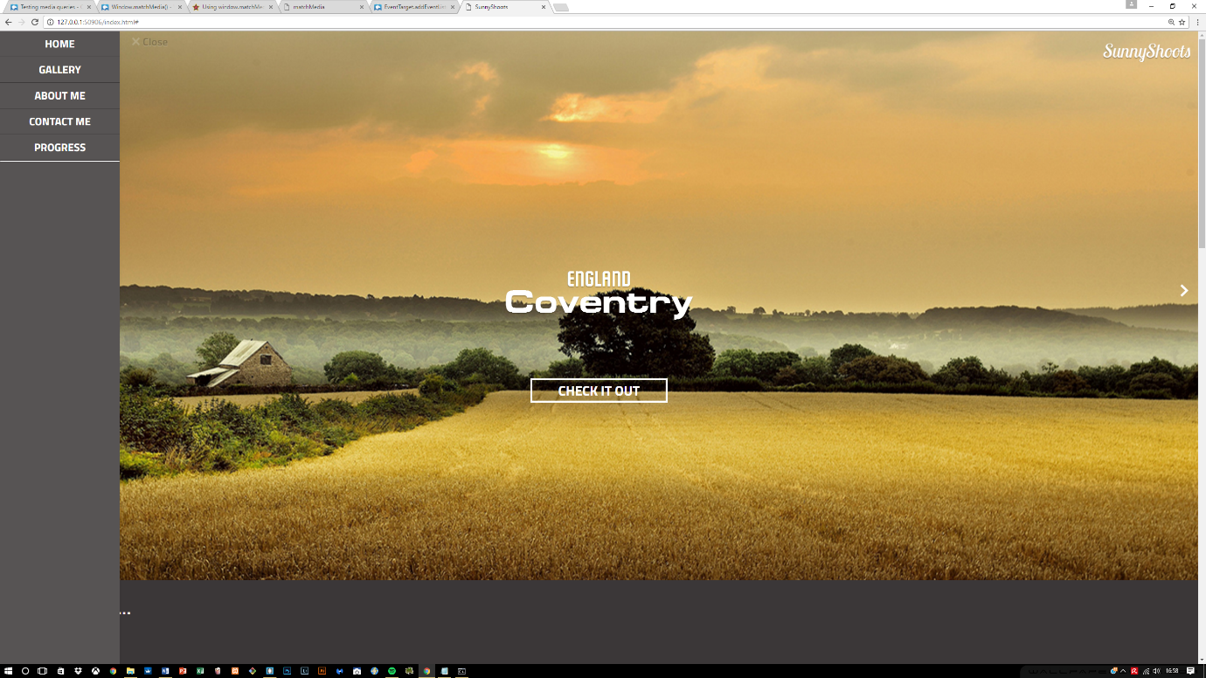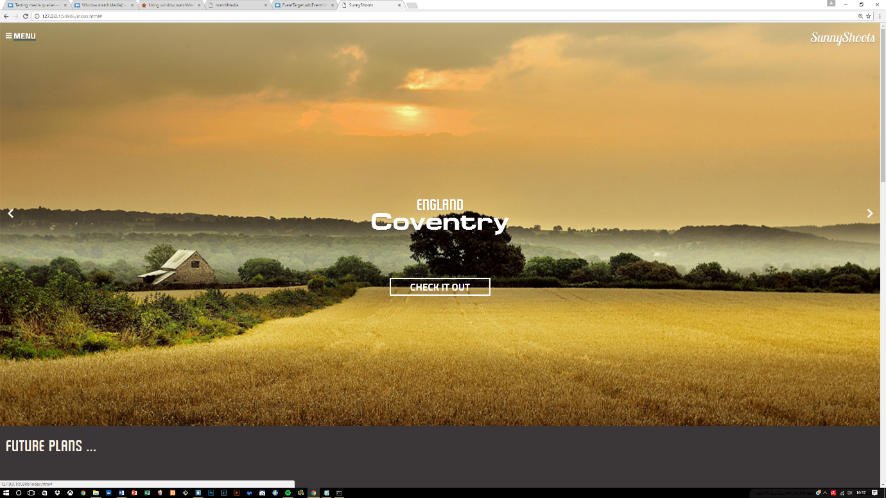Previous navigation bar had to be hidden using the CSS declared for Bootstrap, known as “hidden”. With this the navigation bar was hidden but now within the new changes, using the help of JavaScript it allows the navigation bar to appear and be closed using the Menu and Close buttons.

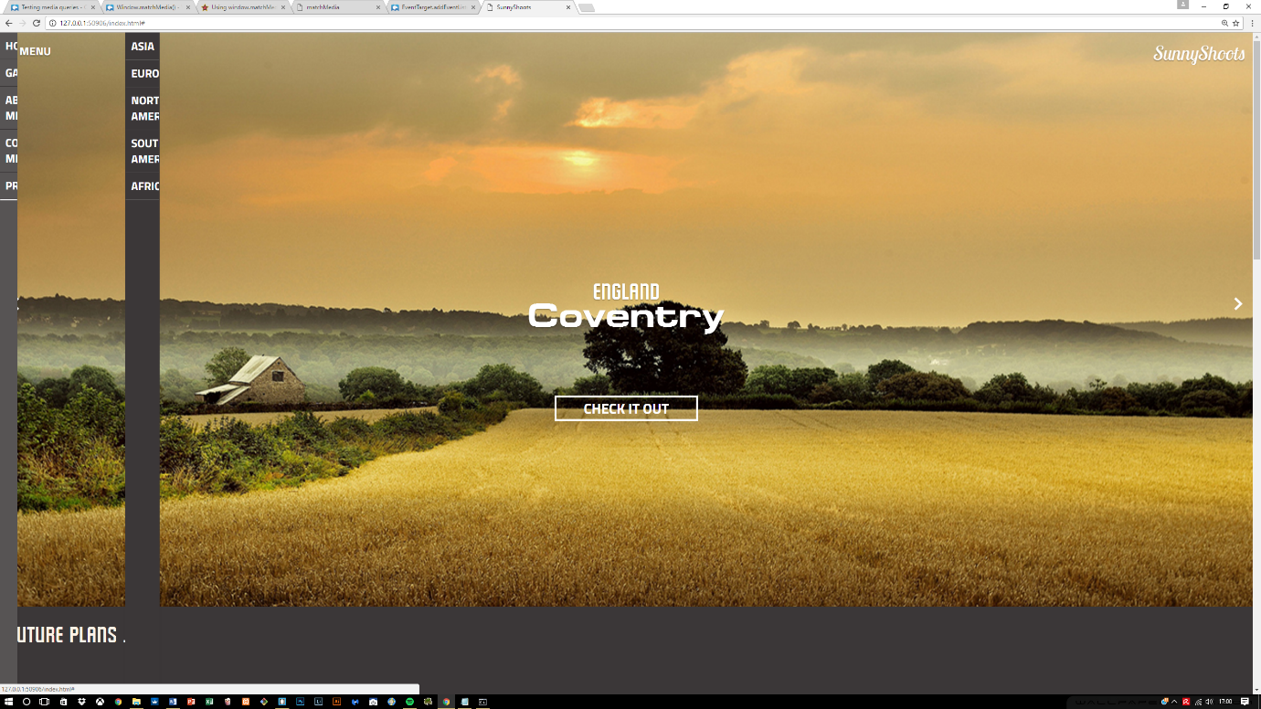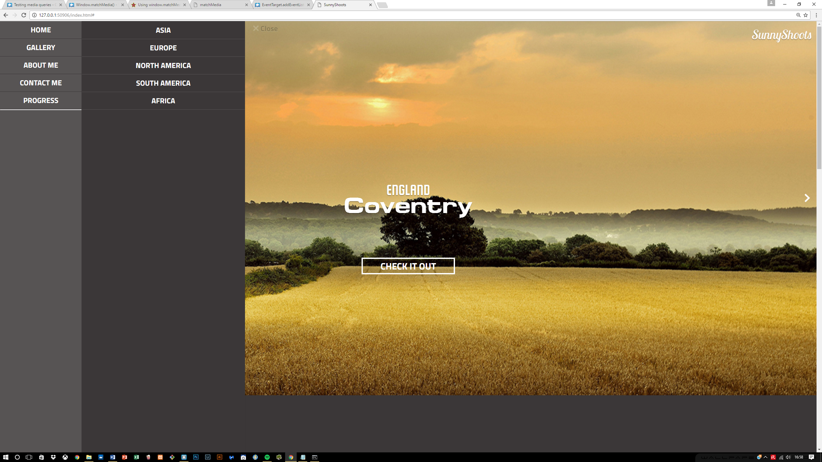

When the close button is clicked, the width is removed within JavaScript for the navigation bar and the transition that is set at 0.5s allows this transitioning to occur creating a nice effect.

The entire navigation bar is done using radio buttons and labels which have been designed within CSS to hide any unwanted properties and allowing thus to maintain the elegancy of the navigation bar. This approach is utilized for testing whether menu can still perform the same way as using anchor tags or unordered lists. The problem with this approach I find is that, it takes a long time to build a menu bar with this approach and a lot of time and configuration that can be easily done with using other tags, is easier compare to this structure.

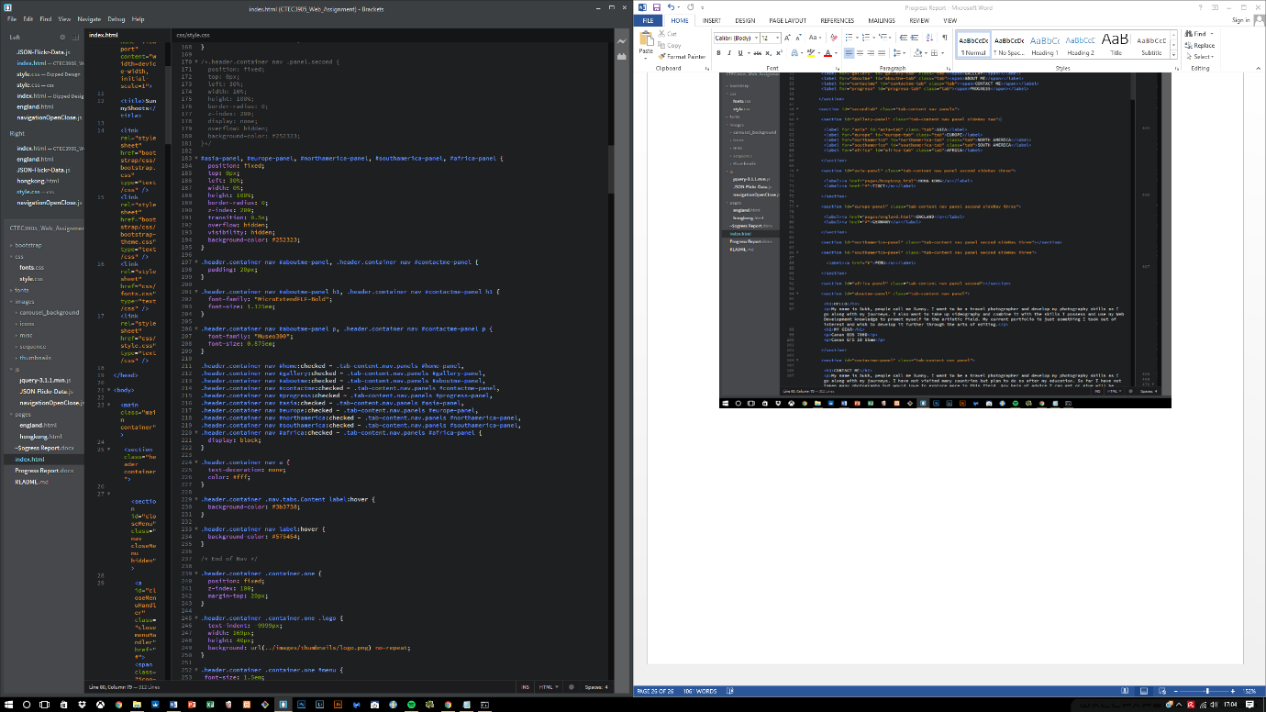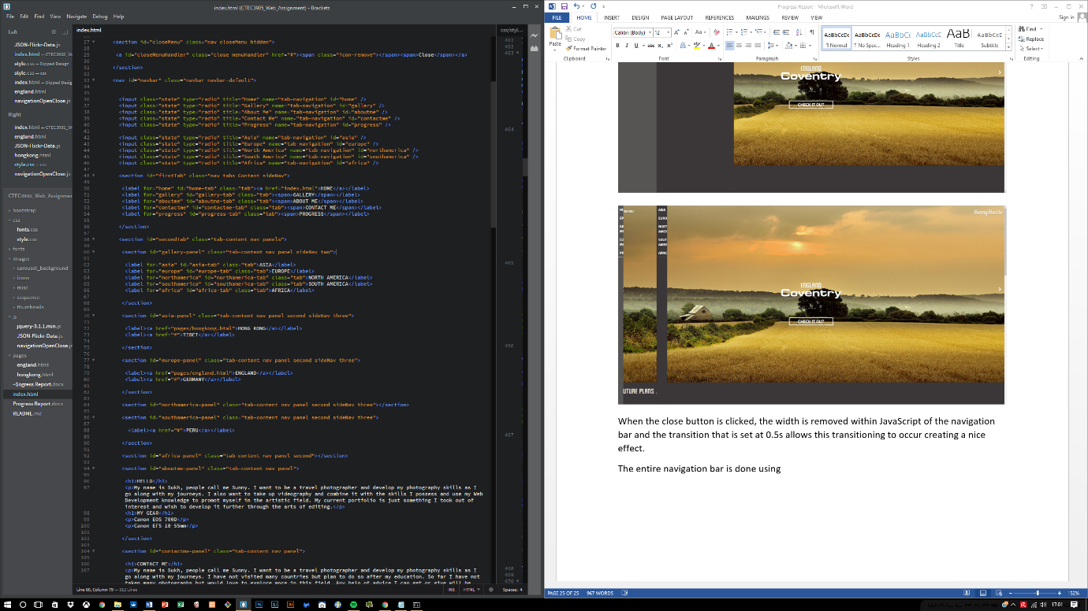The code for this is shown below:

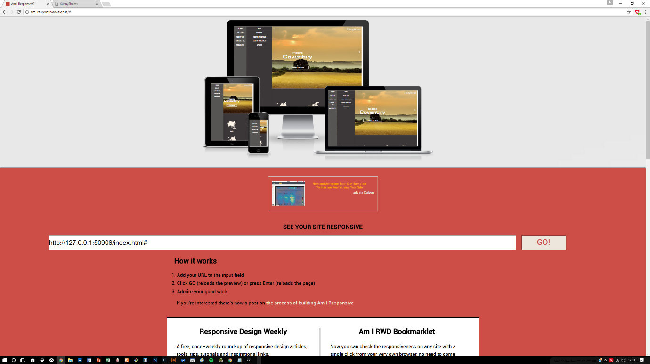At first it seemed impossible to be able to create an interactive menu using labels and radio buttons because of the configuration that needs to go in to it but with the help of JavaScript, it was easy to maintain the responsive aspect of the menu. JavaScript also provides ***window.matchMedia()*** function and with this it was easier to listen for changes within the screen size and helped adopting to the screen sizes.

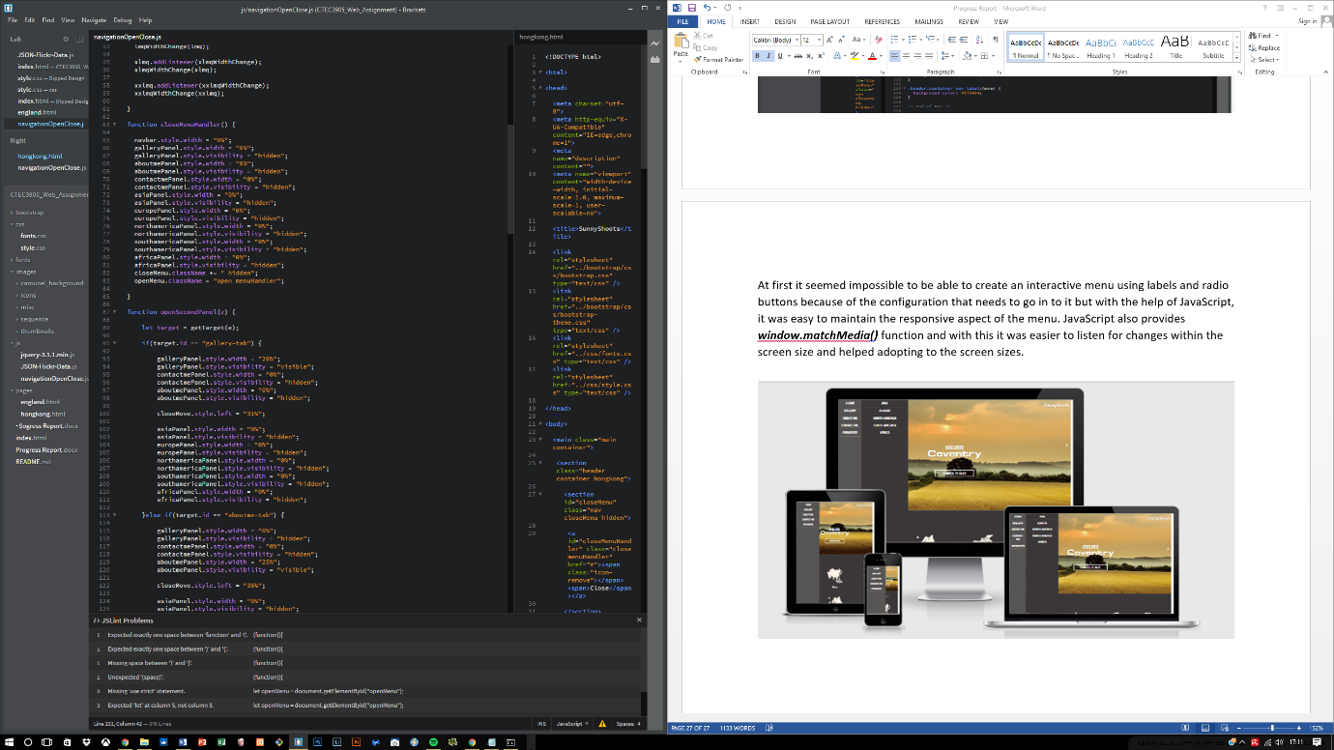

## 6.8 Navigation bar finished

Previous navigation bar dealt with many changes and they included mostly features created in JavaScript. The navigation bar required CSS to hide and show the bar and it did not adjust to different screen sizes, however the new changes and the final changes that have been done to it are of the following:

* No use of “hidden” within the CSS to hide the navigation bar
* Uses menu and close buttons to open and close navigation bar
* With the help of **window.matchMedia(),** it now performs much better when resized, using 5 different media query listeners ranging from the smallest to largest size.
* 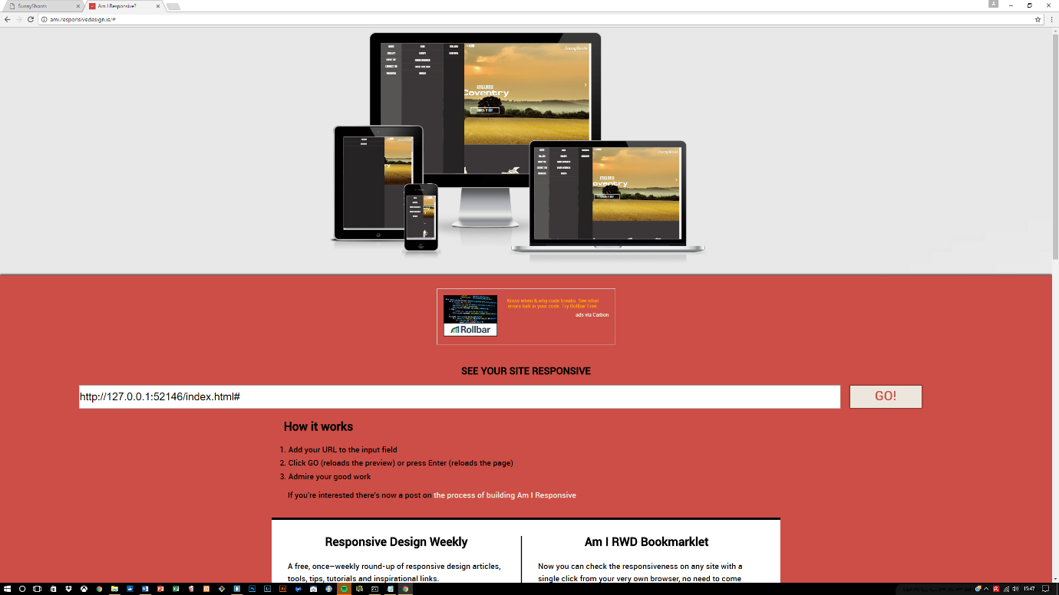Each screen size has a different style of navigation, some are 3 tabbed on larger screens and on smaller screens its 1 tab.

## 6.9 Image hover effect

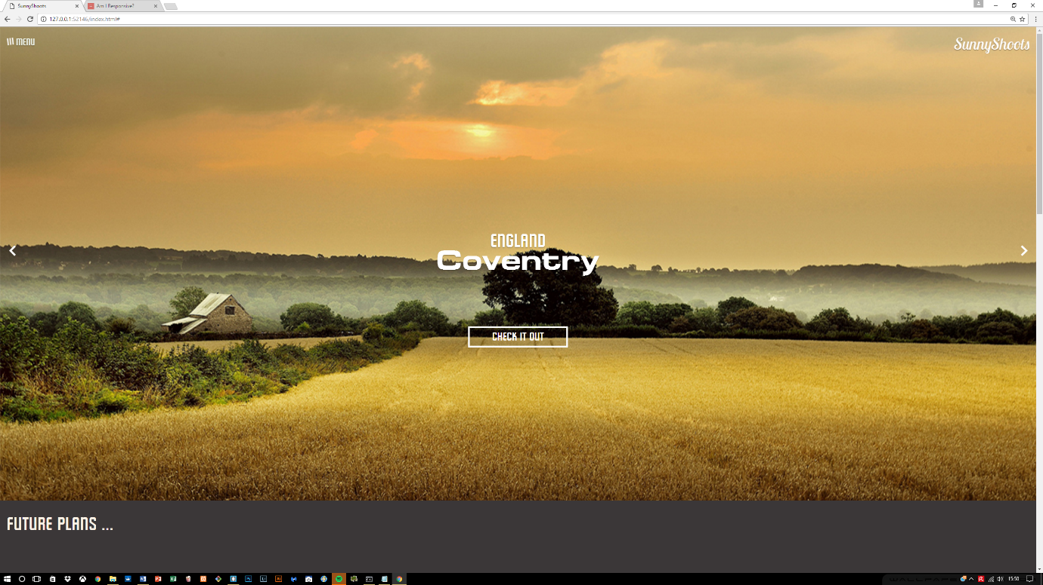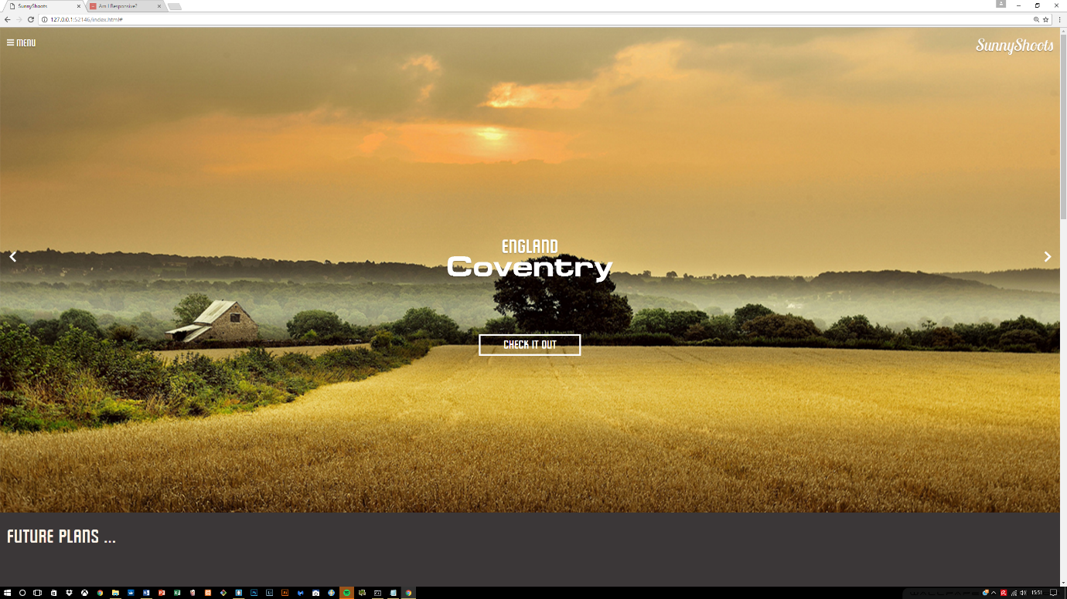With the advancement of CSS3, it provided so many benefits when it came to styling the features on the website. One of the features included hovering over the menu label and the hamburger sign transitioning in a 360 degree angle.

Other areas where this was applied included the countries section, where different countries are being presented. On this a hover effect is applied so that when hovering over the image, the image produces an overlay which is shown below:

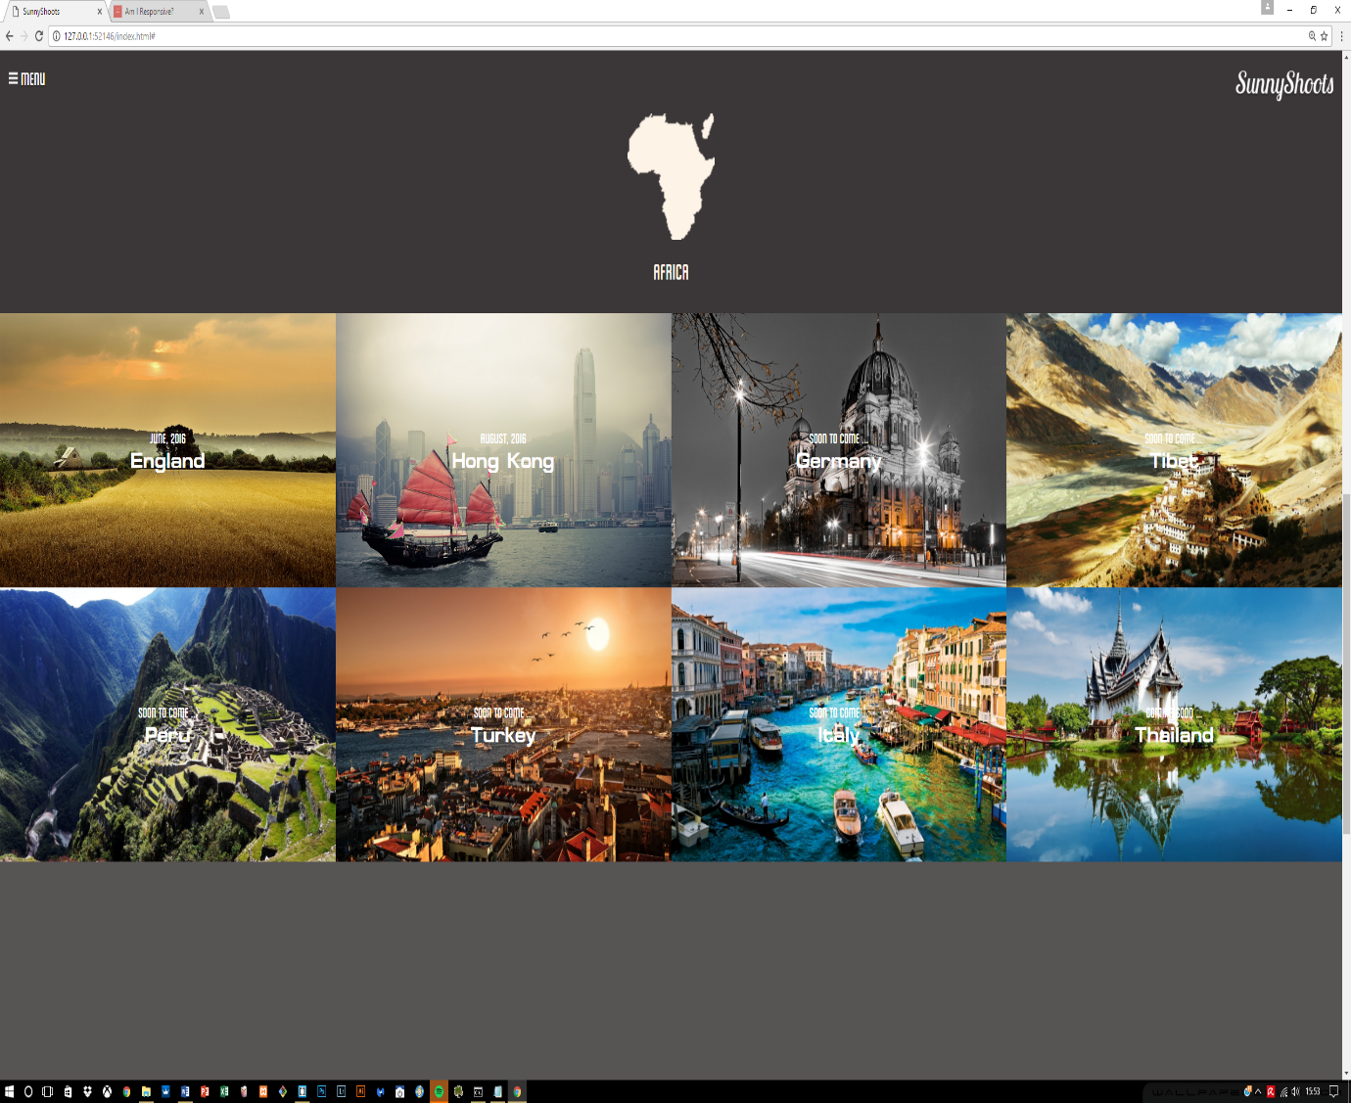

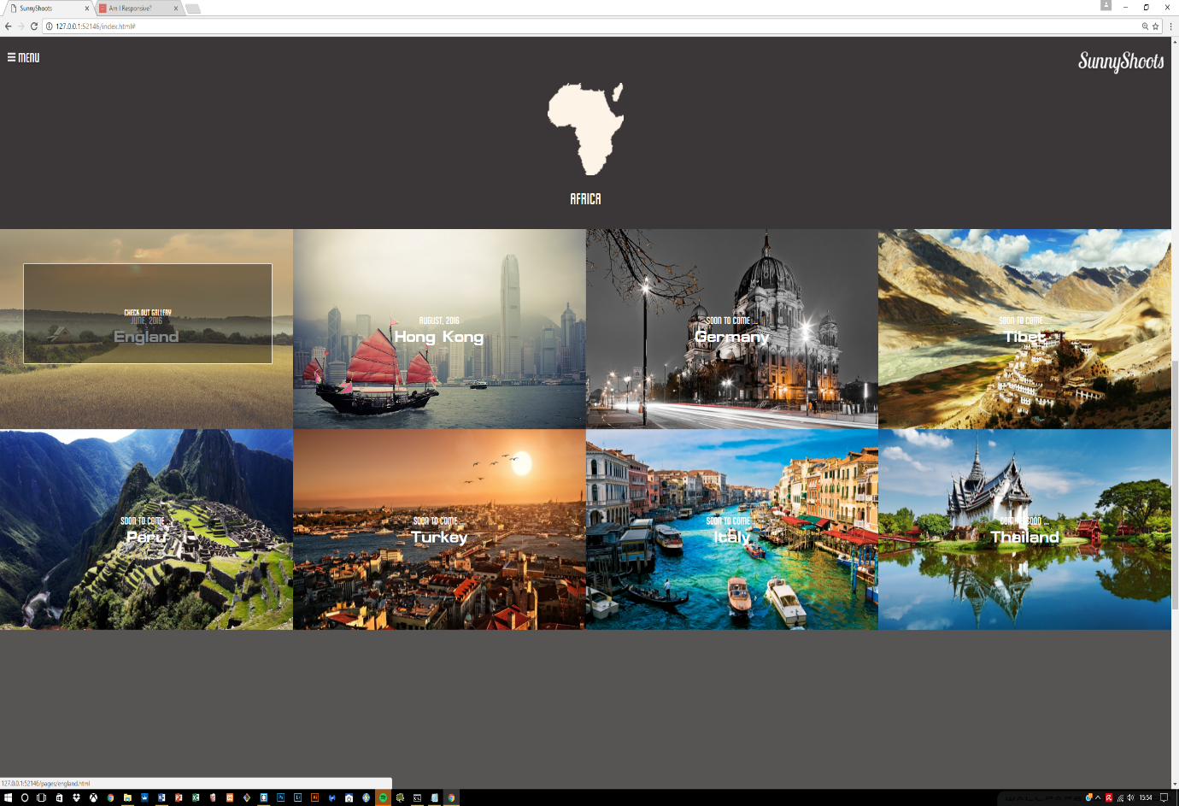

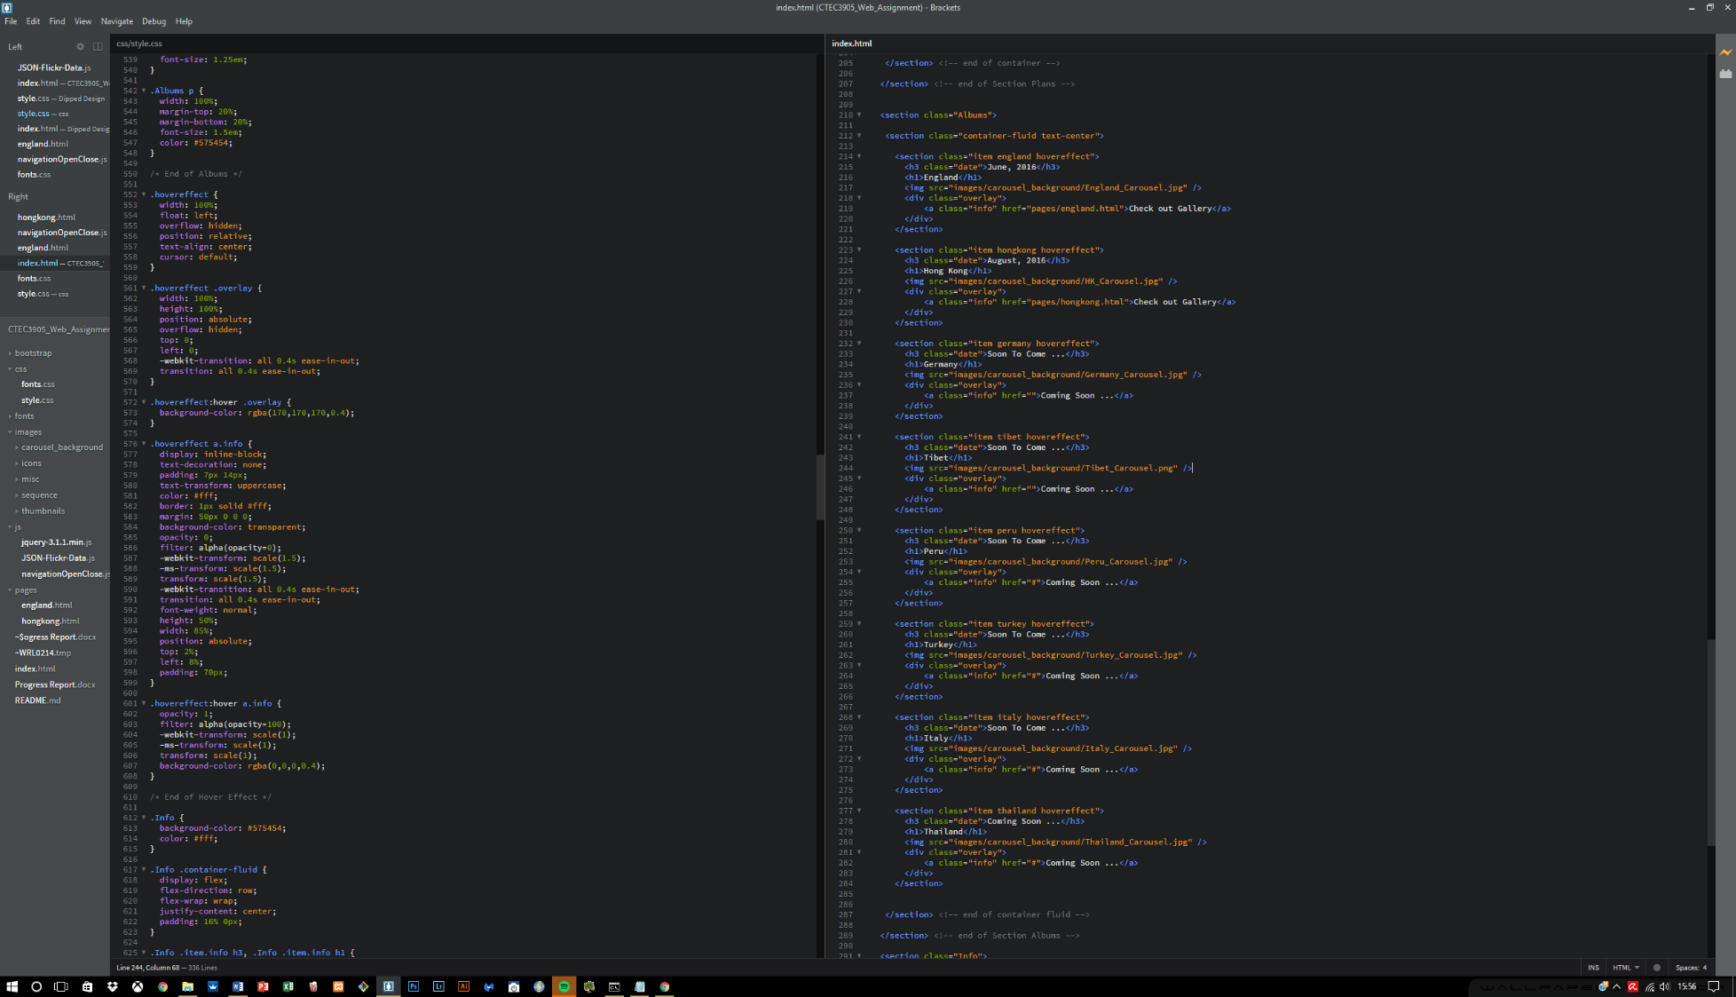This was achieved using HTML classes and CSS to contain and hide the information until required using a hover. The CSS was mainly utilised for decorating the overlay effect. The code is provided below:

## 6.10 Give Background to navigation bar when reached a certain offset

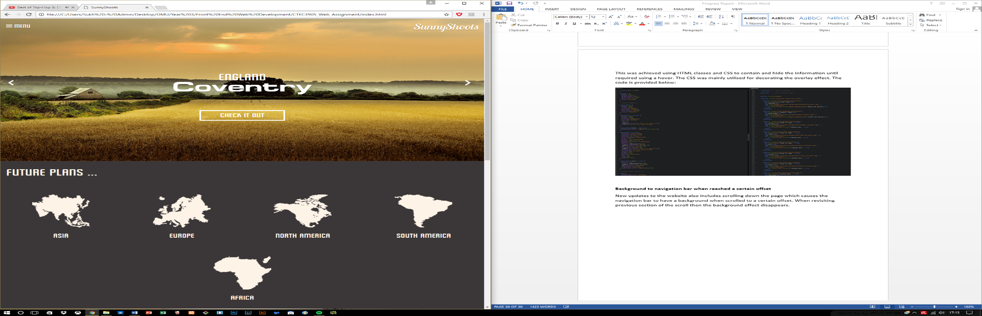New updates to the website also includes scrolling down the page which causes the navigation bar to have a background when scrolled to a certain offset. When revisiting previous section of the scroll then the background effect disappears.

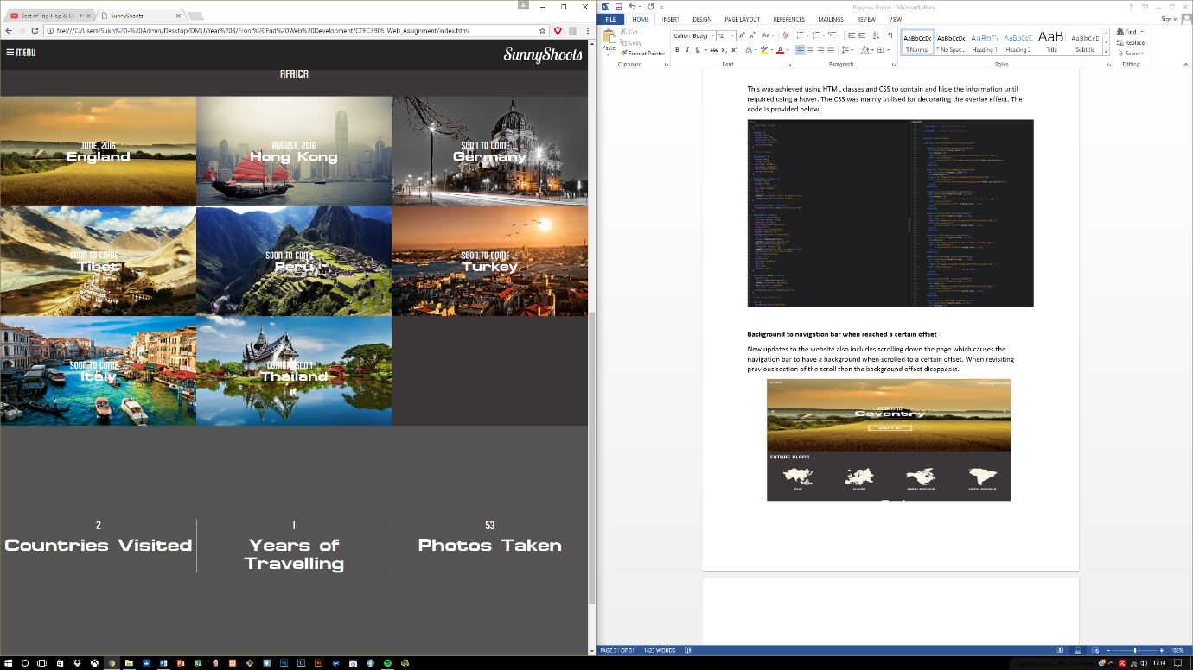

## 6.11 Content in first section animated

When the page is loaded or a new slide is visited, the content on the 1st section gets animated which creates a lively atmosphere to the entire site.

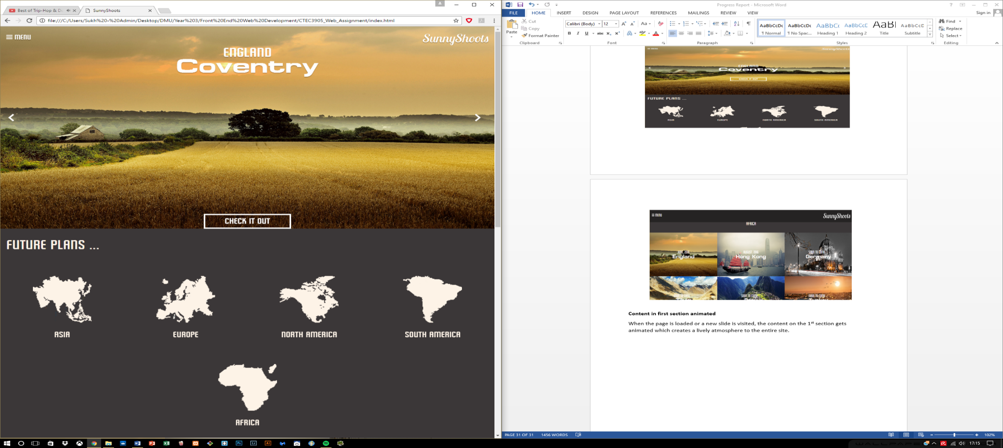

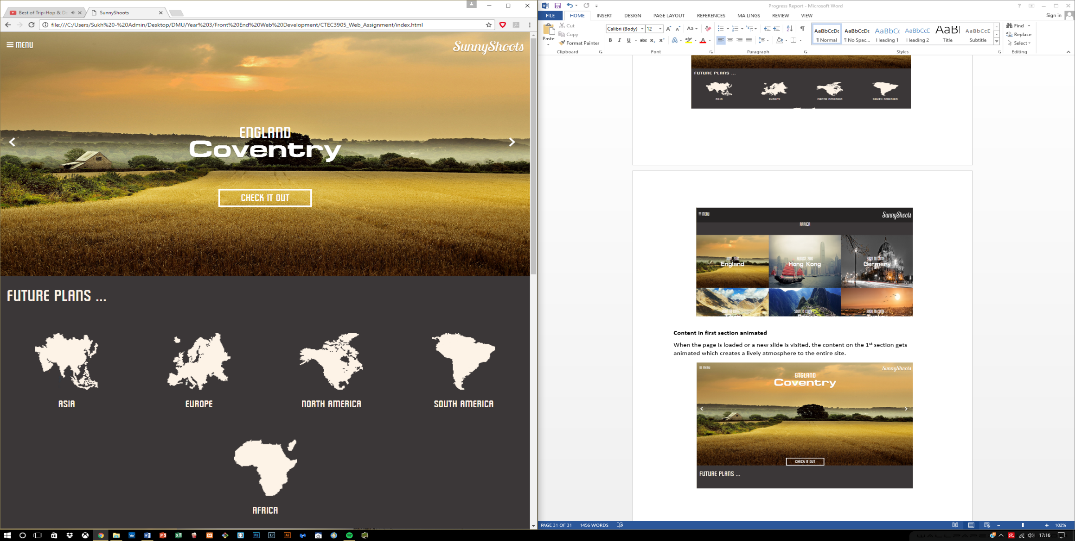

## 6.12 Slider

The slider part has also been added, but due to the layout of the structure not many animations can be done to the individual content that is being displayed within the slider. Therefore a simple animation was added to make it appear more interactive. The sliding however works perfectly in terms of selecting the left or right arrow, the correct content is displayed.

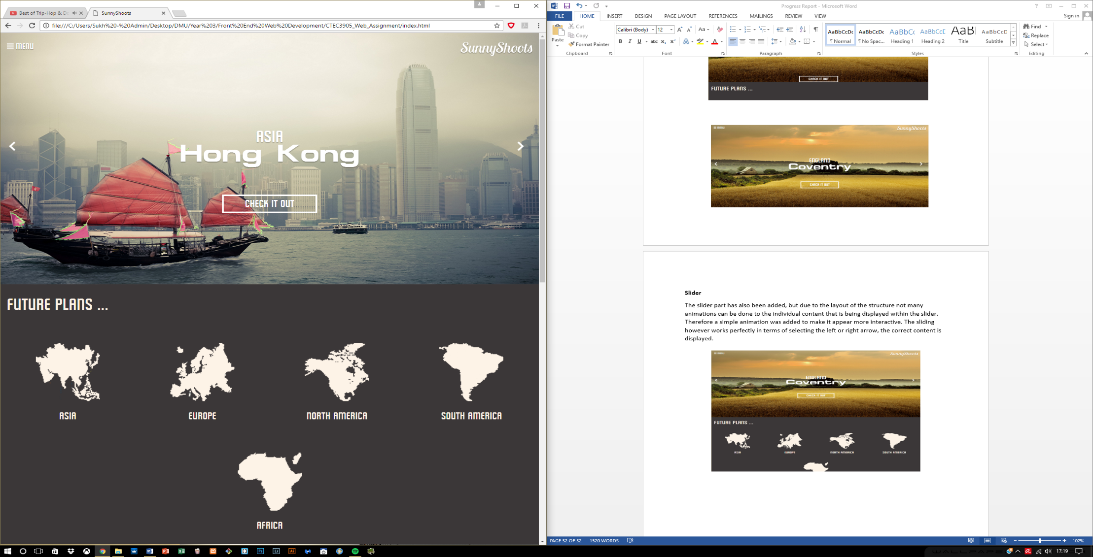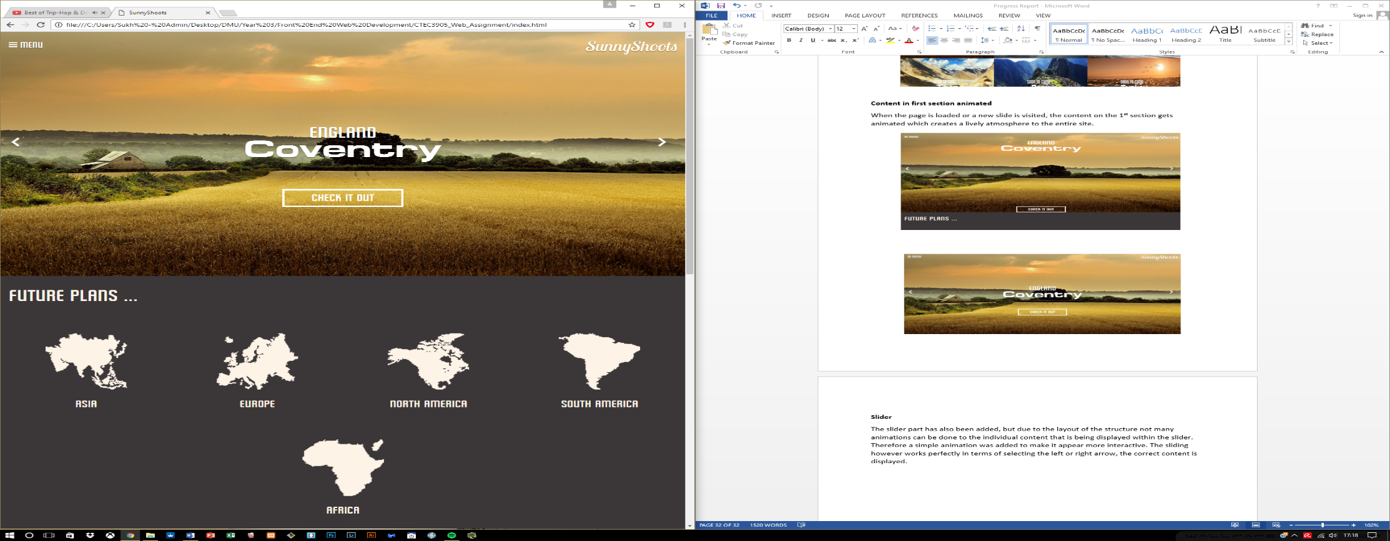

## 6.13 Modal for the images

Last feature that has been added to the current website is the Modal feature which works through the interaction with the images in one of the galleries, if the user happens to click on an image, the Modal is used for expanding the image size so the viewers can see it in an enlarged format.

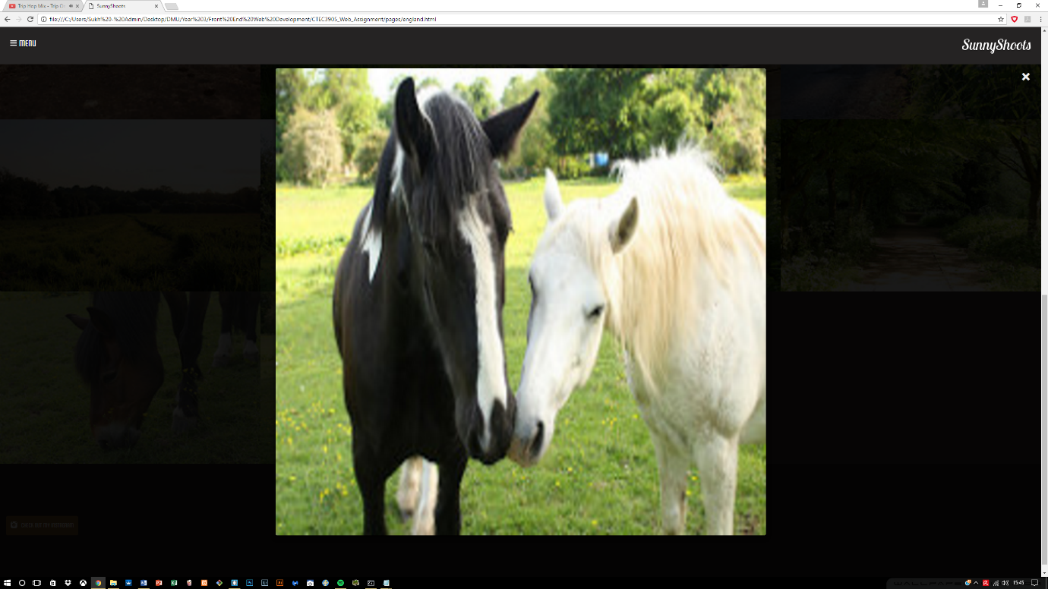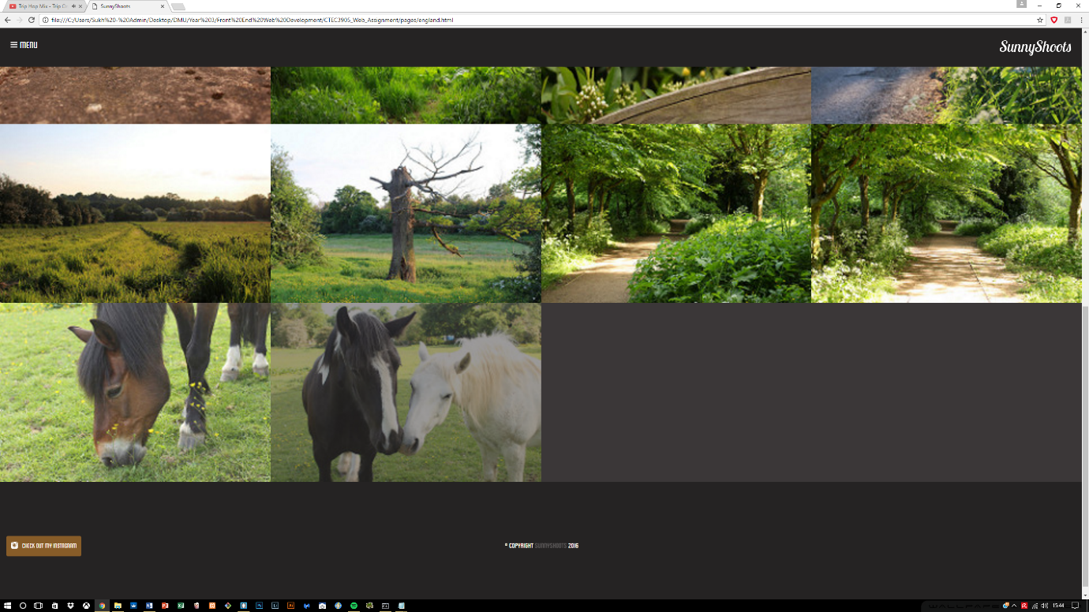This was done using with the help of JavaScript as well as creating a new structure within the HTML and utilized CSS to hide the modal until required through JavaScript.

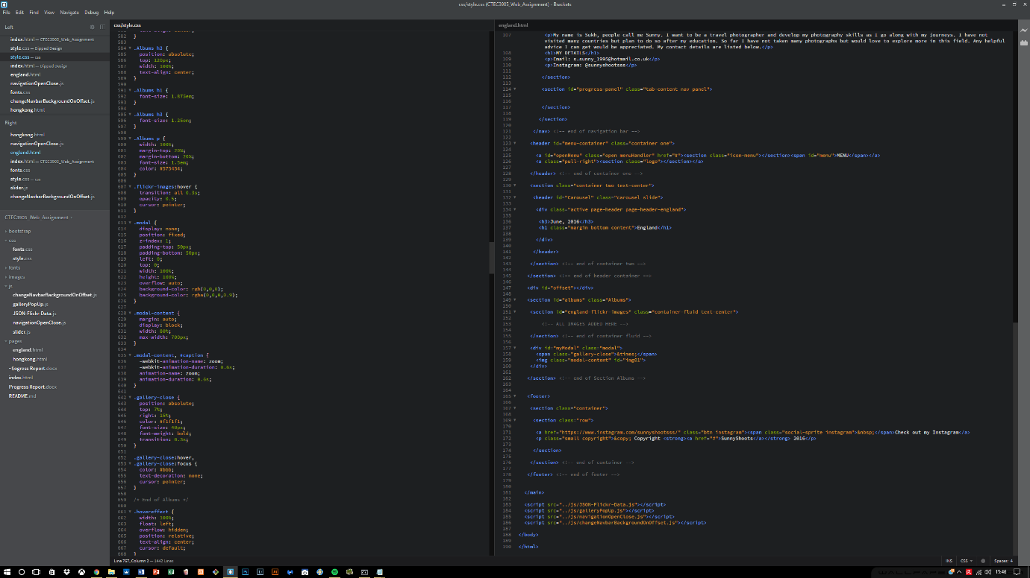

## 6.14 3D flip effect

New updates done to the site include the addition of the flip effect which requires the user to hover over one of the continents, and it displays the information on which countries have been visited by flipping to the back side of the content.

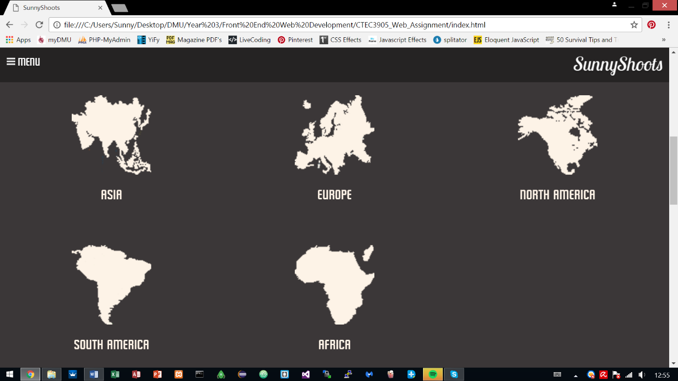This effect was achieved using CSS and required restructuring of the HTML syntax to include two faces which is the front and back. The front face includes details of the information to display to begin with and back face is the information displayed when hovered over.

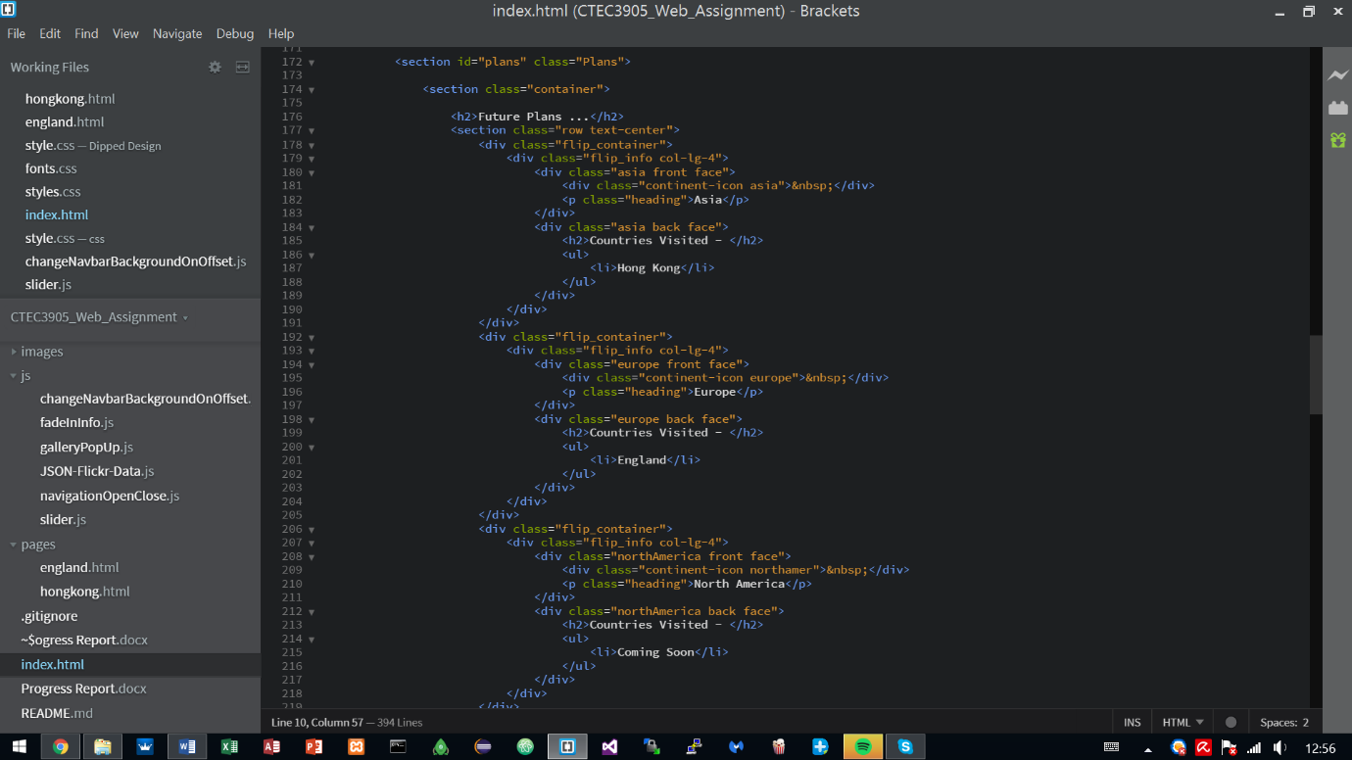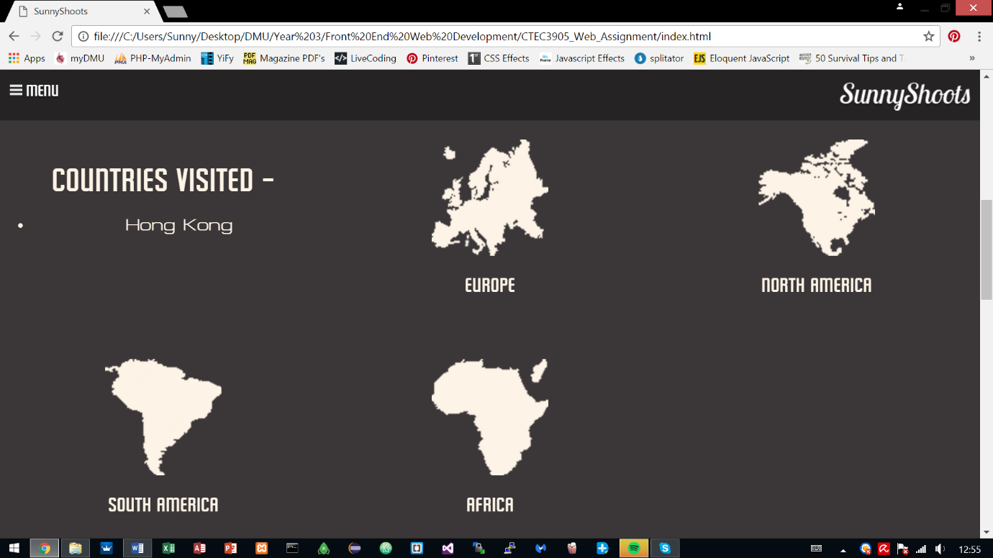

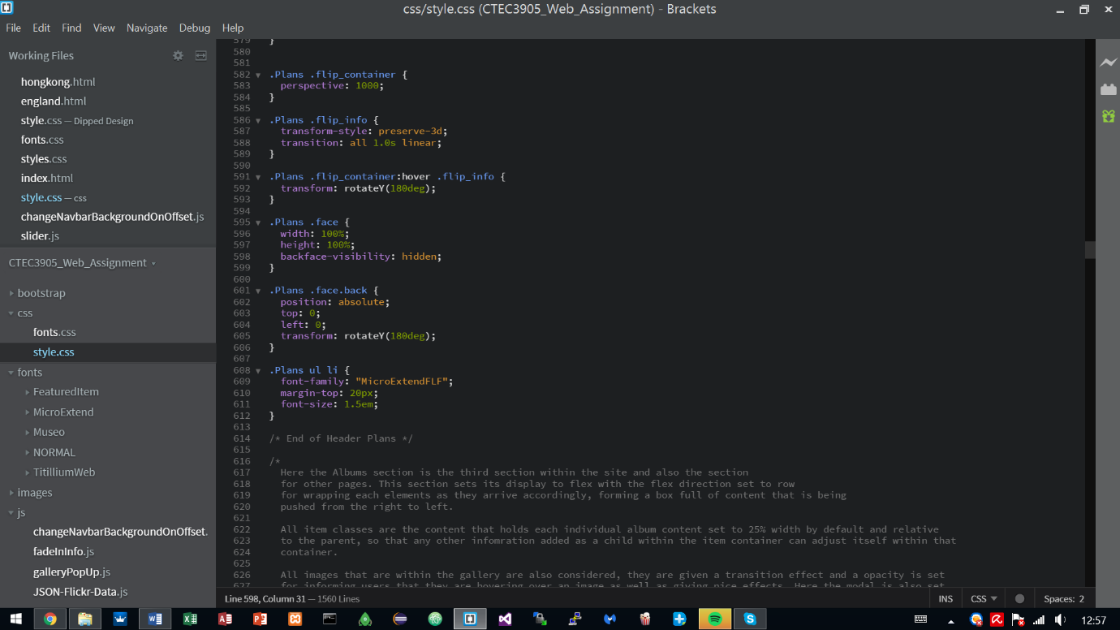

## 6.15 Fading In transition

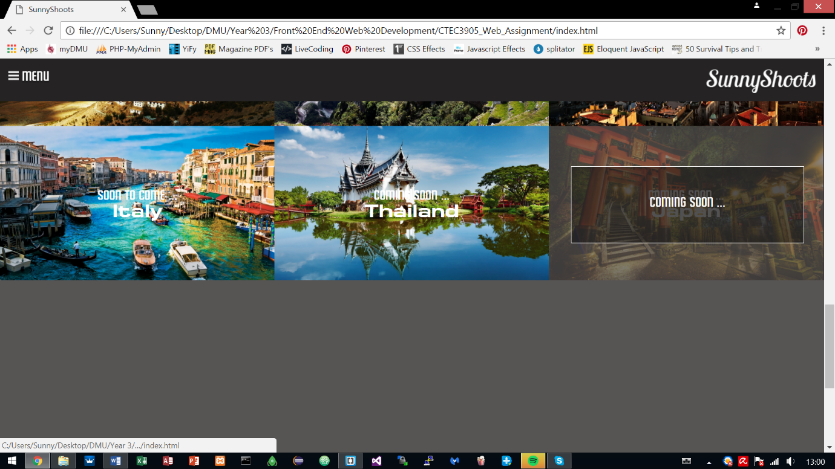This effect was also an update to the site, it required adding in new classes to the current elements within the site. Unlike before, the values are now set to display nothing by changing the **opacity** to **0.** The content is then loaded via JavaScript which checks for the offset, if the offset is triggered then the fading in begins.

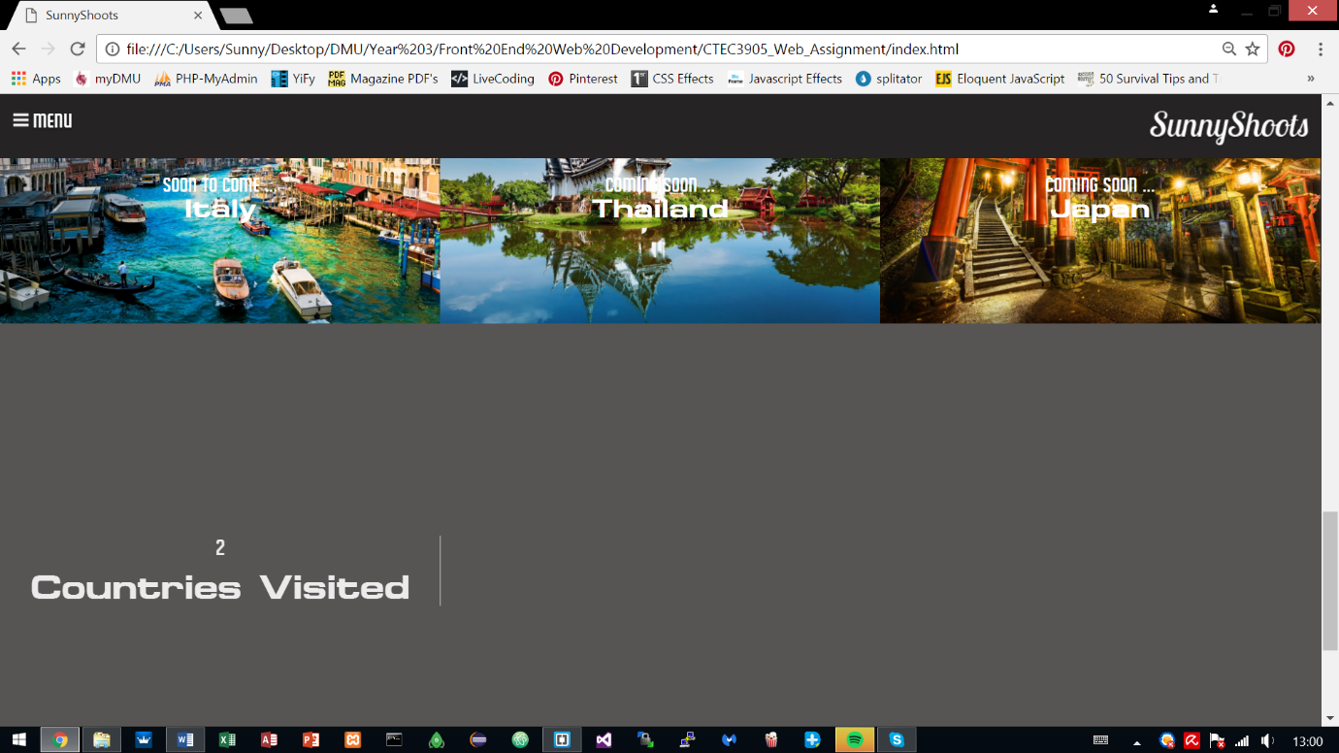

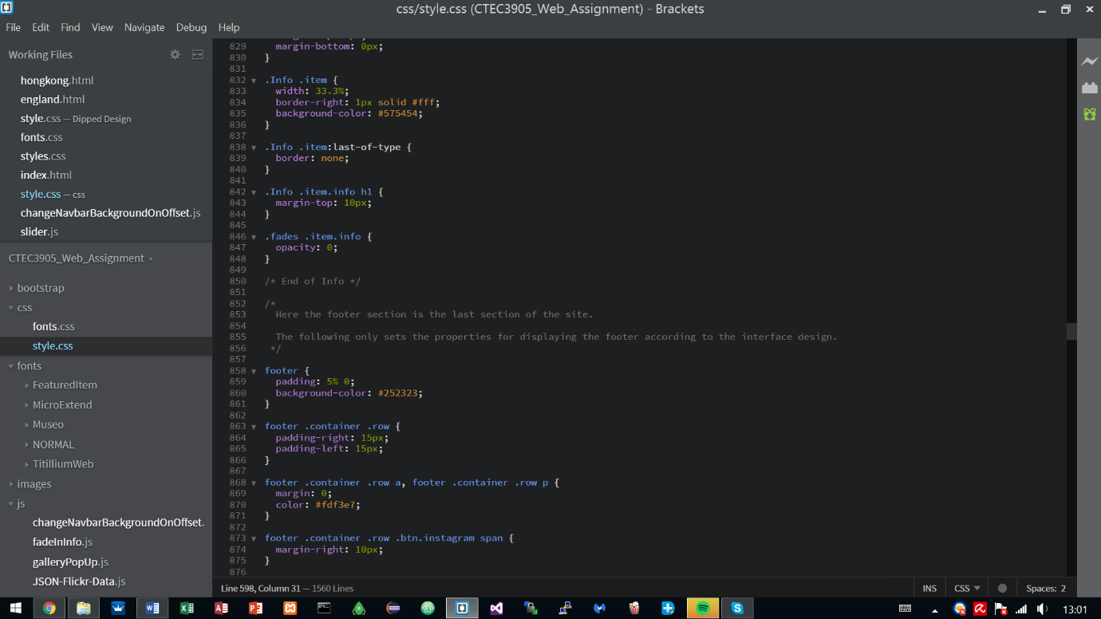

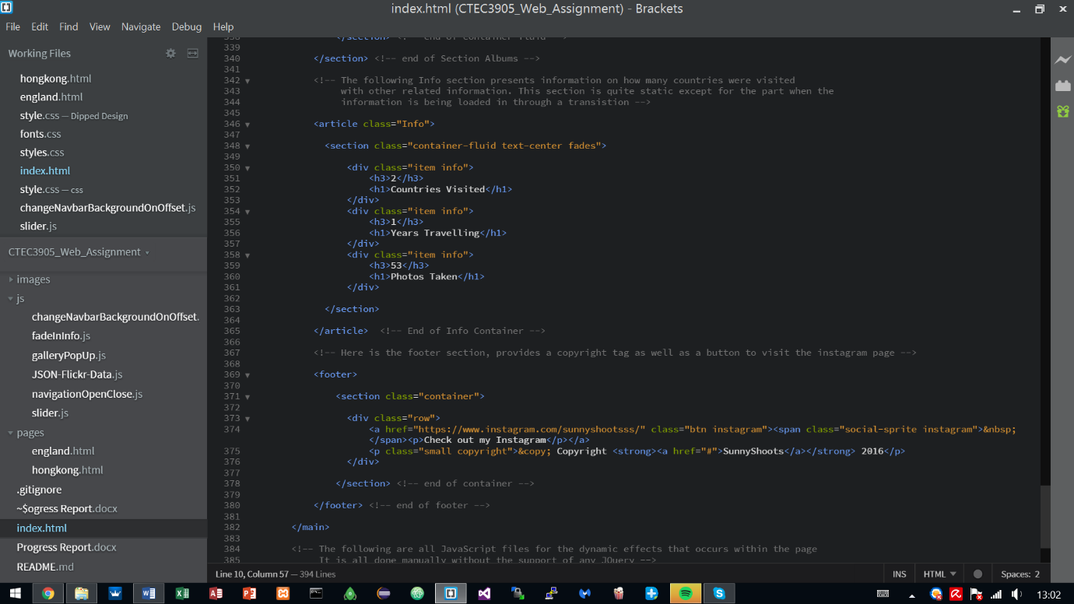

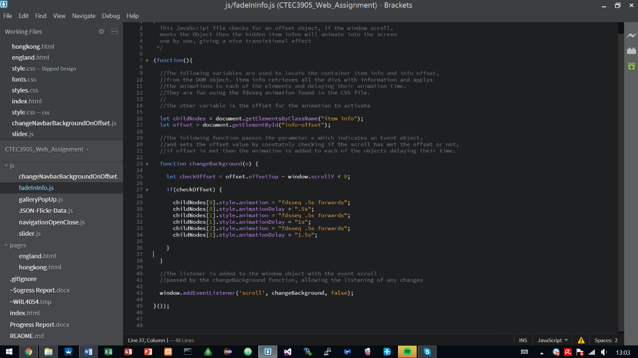

# Information Architecture and PARC

Overall the entire website conforms to Information Architecture, taking into consideration the structuring and classifying of the items within the website into their own individual sections, helping people to find and manage information. The website does not compress all the information together and lays out the information in a way that is pleasing to look at and easy on the eye.

It takes into consideration the users, which will mainly be photographers as the audience and therefore the website conveys the information through the contents which are the images to this audience without having to read or go through a long process of discovery before getting to where they want to go.

The content is mainly images centric, but as a portfolio site it provides a little information about the creator of the site. The context of this website is to provide a general means to promote the images or just for viewing pleasures.

The website takes into consideration the PARC rules.

Proximity has been applied where the items belong together, this was done using semantic syntax ‘**section**’ to provide the differentiation between other groups.

Alignment has been applied throughout the site using grids, keeping the site in order and providing a holistic feel.

Repetition has been applied to various text styles and sizes.

Contrast was also applied, again similar to proximity, it is the contrasting between two individual groups/items.

# Validation HTML5

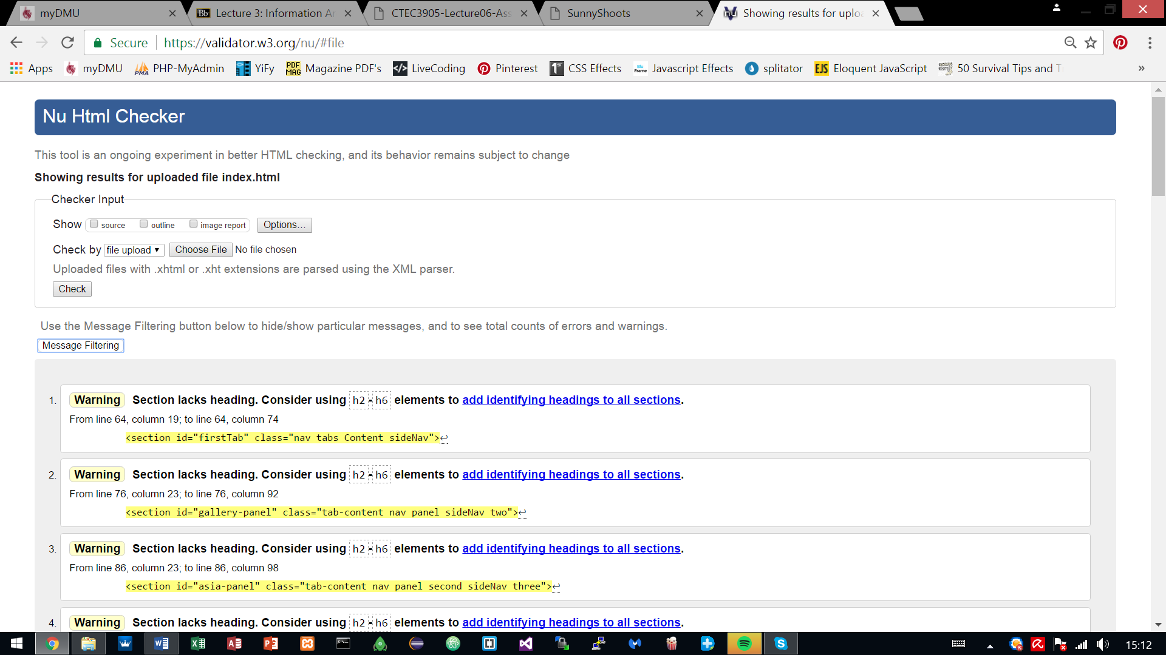The website has been validated to meet HTML5 standard syntax. It complies with the rules of the HTML5 and avoids any **errors**. However there are **warnings** to some parts of the code but it requires the addition of several heading tags to sections which does not comply with the websites intention/purpose, therefore they were not added.

# Sitemap

# 10. User Testing/Accessibility

The following video link shows the process of a user testing the site. They are users who have never visited the site before and are given instructions on where to go, which they discover by themselves. The tasks were easily performed without any hesitations.

<https://www.youtube.com/watch?v=WrscTp8xRa4&feature=youtu.be>

A website named **achecker** also provided some good feedback in terms of identifying potential and known problems. The problems are not corrected but gave an understanding to how a future project may be approached. Despite the problems, there were also success criteria’s in the following categories:

* Distinguishable: Make it easier for users to see and hear content, has contrast.
* Navigable: Provide ways to help users navigate, find content, and determine where they are
* Text Alternatives: Provide text alternatives for any non-text content
* Adaptable: Create content that can be presented in different ways
* Seizures: Did not design content in a way that is known to cause seizures
* Readable: Make text content readable and understandable
* Predictable: Make Web pages appear and operate in predictable ways
* Input Assitance: Help users avoid and correct mistakes

# References

<http://stackoverflow.com/questions/21168846/cant-remove-file-from-git-commit>

<https://git-scm.com/book/en/v2/Git-Internals-Maintenance-and-Data-Recovery#Removing-Objects>

<http://worldinmylens.com/>

<http://stackoverflow.com/questions/24259016/responsive-menu-show-and-hide-on-click>

<http://bootsnipp.com/snippets/featured/radio-button-tabs>

<http://www.w3schools.com/cssref/tryit.asp?filename=trycss_background-attachment_fixed>

<http://stackoverflow.com/questions/18071046/smooth-scroll-to-specific-div-on-click>

<https://miketricking.github.io/dist/>

<http://www.lovelldsouza.com/webdev/flickr-to-website/>

<http://alistapart.com/article/radio-controlled-web-design>